(LRGVDC Contract No. 2021-01)

**AGREEMENT BETWEEN THE LOWER RIO GRANDE VALLEY DEVELOPMENT COUNCIL AND Research, Applied Technology, Education and Service, Inc. (RATES).**

This Agreement is by and between the Lower Rio Grande Valley Development Council, 301 W. Railroad St., Weslaco, Texas. 78596 (hereafter referred to as “LRGVDC”) and Research, Applied Technology, Education and Service, Inc. (“RATES”), P.O. Box 697 Edinburg, TX 78540 Texas 78539, hereafter referred to as (“Subrecipient”). The term “Contract Documents” in this document is defined as this Agreement and the exhibits that follow, Exhibits A, B, C, D and E.

**RECITALS**

**WHEREAS,** the LRGVDC desires to engage the Subrecipient to perform certain functions on behalf of the LRGVDC under the TWDB Contract No. 40038 and receive payment from funds Texas Water Development Board (“TWDB”) has funded to the LRGVDC for TWDB Contract No. 40038 for the subcontracted work performed by Subrecipient and certain services in connection therewith; and,

**WHEREAS,** Subrecipient represents that it has the knowledge, ability, equipment, and personnel to properly provide the services and scope of work needed by the LRGVDC;

**WHEREAS**, Subrecipient understands that this Agreement is in effect contingent on approval by TWDB. If this Agreement isn’t approved or deemed ineligible for any reason by TWDB, cancellation of this Agreement will occur, and any work completed by the subrecipient prior to the approval of this Agreement by TWDB will be at subrecipient’s expense.

**NOW, THEREFORE,** the LRGVDC and Subrecipient do mutually agree as follows:

**SECTION I**

**EMPLOYMENT OF SUBRECIPIENT**

LRGVDC agrees to employ Subrecipient to provide certain services on behalf of the LRGVDC under TWDB Contract No. 40038 as stated in Exhibit A in this Agreement. Additionally, the following are incorporated into the Agreement as if set out verbatim.

* The project requirements and related documents and Addenda contained in the MOA with LRGVDC and RATES and the exhibits in this Agreement.

Upon receipt of such satisfactory services and subject to sufficient TWDB funding, LRGVDC agrees to pay Subrecipient as stated in the sections to follow.

**SECTION II**

**SUBRECIPIENT SERVICES**

The Subrecipient agrees to perform the work in connection therewith, under the terms of this Subrecipient Agreement for all activities described herein at its own proper cost and expense to furnish all the labor, insurance and other accessories and services necessary to complete the said tasks in accordance with the conditions and prices stated in this Agreement, any addenda, and including all documents submitted to the TWDB in response to any documents related to funding provided by TWDB for this Agreement which includes the scope of work, and associated tasks.

**SECTION III**

**QUALIFYING CONDITIONS**

1. The Subrecipient recognizes and agrees that failure to deliver the service in accordance with the delivery schedule detailed in Exhibit C to this Agreement will result in expense and damage to the Subrecipient. The Subrecipient shall inform the LRGVDC immediately of any anticipated delays in the delivery schedule and of any remedial actions being taken to ensure completion of the service according to such schedule. If the agreed completion date is missed and remedial actions are not taken by the Subrecipient, the LRGVDC may, in its sole discretion, declare such delay a material breach of this Agreement and pursue all of its legal and equitable remedies. The LRGVDC may not declare a breach, and the Subrecipient cannot be held in breach of this Agreement, of this section if such delay is caused by an action or failure of action of the LRGVDC. In such case, the Subrecipient will provide the LRGVDC with written notice of the delay and work until the reason for the delay has been resolved by the LRGVDC and written notice of that resolution has been provided to the Subrecipient.
2. The Subrecipient is under no obligation or restriction that would in any way interfere or conflict with the work to be performed by the Subrecipient under this Agreement. The LRGVDC understands that the Subrecipient may currently be working on one or more similar projects for other customers. Provided that those projects do not interfere or conflict with the Subrecipient’s obligations under this Agreement, those projects shall not constitute a violation of this Agreement by the Subrecipient.
3. Except as expressly agreed otherwise in writing by the LRGVDC, the Subrecipient shall bear all of its own expenses arising from its performance of its obligations under this Agreement. The LRGVDC shall have no obligation to provide office space, work facilities, equipment, clerical services, programming services, or the like.
4. Subrecipient is responsible for initiating, maintaining, and supervising all safety precautions and programs in connection with the work. The safety program shall comply with all applicable requirements of the Occupational Safety and Health Act of 1970.

**SECTION IV**

**SUBRECIPIENT’S SPECIAL WARRANTIES AND RESPONSIBILITIES**

Subrecipient agrees and acknowledges that the LRGVDC is entering into this Agreement in reliance on Subrecipient's represented expertise and ability to provide services. Subrecipient agrees to use its best efforts, skill, judgment, and abilities to perform its obligations and to further the interests of the LRGVDC in accordance with LRGVDC’s requirements and procedures.

Subrecipient represents and agrees that it will perform its services in accordance with the usual and customary standards of Subrecipient’s profession or business and in compliance with all applicable national, federal, state, and municipal, laws, regulations, codes, ordinances, orders and with those of any other body having jurisdiction over the project. Subrecipient agrees to bear the full cost of correcting Subrecipient’s negligent or improper work and services, and any to the extent harm caused by the negligent or improper work or services. LRGVDC shall bear the full cost of correcting issues created by LRGVDC’s or any other party’s negligent or improper work and services.

Subrecipient's duties shall not be diminished by any approval by LRGVDC nor shall the Subrecipient be released from any liability by any approval by LRGVDC, it being understood that the LRGVDC is ultimately relying upon the Subrecipient’s skill and knowledge in performing the services required by this Agreement.

Subrecipient represents and agrees that all persons connected with the Subrecipient directly in charge of its services are duly registered and/or licensed under the laws, rules and regulations of any authority having jurisdiction over the Project if registration is required.

Subrecipient represents and agrees to advise LRGVDC of anything of any nature in any drawings, specifications, plans, sketches, instructions, information, requirements, procedures, and other data supplied to the Subrecipient (by the LRGVDC or any other party) that is, in its opinion, unsuitable, improper, or inaccurate for the purposes for which the document or data is furnished.

The Subrecipient represents and agrees to perform its services under this Agreement in a prompt and economical manner consistent with good business practices and the interests of LRGVDC.

Subrecipient represents and agrees that the individual executing this Agreement on behalf of Subrecipient has been duly authorized to act for and to bind Subrecipient to its terms.

Subrecipient shall designate a representative authorized to act on Subrecipient’s behalf with respect to the project.

Except for the obligation of the LRGVDC to pay Subrecipient certain fees, costs, and expenses pursuant to the terms of this Agreement, the LRGVDC shall have no liability to Subrecipient or to anyone claiming through or under Subrecipient by reason of the execution or performance of this Agreement, except to the extent due to negligence or willful misconduct of LRGVC. Notwithstanding any obligation or liability of the LRGVDC to Subrecipient, no present or future partner or affiliate of the LRGVDC or any agent, officer, director, employee, or the components comprising the LRGVDC, or anyone claiming under the LRGVDC has or shall have any personal liability to Subrecipient or to anyone claiming through or under Subrecipient by reason of the execution or performance of this Agreement.

Subrecipient agrees and acknowledges that it is subject to all applicable requirements of the master contract between the Lower Rio Grande Valley Development Council and the Texas Water Development Board. Subrecipient adopts by reference the requirements of Article VII of the TWDB Contract for this Subrecipient Agreement.

Each Subcontract the Subrecipient would enter into to perform required work under this Subrecipient Agreement must contain the following:

A. A detailed budget estimate with specific cost details for each task or specific item of work to be performed by the Subcontractor and for each category of reimbursable expenses.

B. A clause stating the following: “Subcontractor agrees and acknowledges that it is subject to all applicable requirements of the master contract between (Contractor Name) and the Texas Water Development Board. Subcontractor adopts by reference the requirements of Article VII of the TWDB Contract for this Subcontract.”

Additionally,

1. the Subrecipient is subject to audit by the Texas State Auditor’s Office, and Subrecipient must cooperate with any request for information from the Texas State Auditor, as further described in Section VII, Paragraph K;
2. payments under the Subcontract are contingent upon appropriation of funds by the Texas Legislature, as further described in Section VII, Paragraph C;
3. ownership of data, materials and work papers, in any media, that is gathered, compiled, adapted for use, or generated by Subrecipient will become data, materials and work owned by TWDB and Subrecipient will have no proprietary rights in such data, materials and work papers, except as further described in Section XXVI, Ownership.
4. Subrecipient must keep timely and accurate books and records of accounts according to Generally Accepted Accounting Principles;
5. Subrecipient is solely responsible for securing all required licenses and permits from local, state and federal governmental entities and solely responsible for obtaining sufficient insurance in accordance with the general standards and practices of the industry or governmental entity; and
6. Subrecipient is an independent contractor and LRGVDC nor TWDB have no liability resulting from any failure of Subrecipient that results in breach of contract, property damage, personal injury or death.

**SECTION V**

**INDEMNITY AND HOLD HARMLESS**

Each party covenants and agrees to FULLY INDEMNIFY and HOLD HARMLESS, the TWDB, the other party and the elected and appointed officials, employees, officers, directors, volunteers, and representatives of the other party individually or collectively, from and against any and all third-party costs, claims, liens, damages, losses, reasonable expenses, fees, fines, penalties, proceedings, actions, demands, causes of action, liability and suits of any kind and nature, including but not limited to, personal or bodily injury, death or property damage, made upon the other party directly to the extent arising out of, resulting from or related to the other party’s negligent or willful activities under this Subrecipient Agreement, including any negligent or willful acts or omissions of the other party, or any agent, officer, director, representative, employee, and their respective officers, agents, employees, directors and representatives while performing under this Subrecipient Agreement. The indemnity provided for in this paragraph does not apply to any liability resulting from the negligence of the other party, its officers or employees, separate Subrecipients or assigned Subrecipients, in instances where such negligence causes personal injury, death or property damage. IN THE EVENT SUBRECIPIENT AND THE LRGVDC ARE FOUND JOINTLY LIABLE BY A COURT OF COMPETENT JURISDICTION, LIABILITY WILL BE APPORTIONED COMPARATIVELY IN ACCORDANCE WITH THE LAWS OF THE STATE OF TEXAS, WITHOUT WAIVING ANY GOVERNMENTAL IMMUNITY AVAILABLE TO THE STATE UNDER TEXAS LAW AND WITHOUT WAIVING ANY DEFENSES OF THE PARTIES UNDER TEXAS LAW.

The provisions of this indemnification are solely for the benefit of the parties hereto and not intended to create or grant any rights, contractual or otherwise, to any other person or entity. Each party shall promptly advise the other party in writing of any claim or demand against the other party which involves actions related to or arising out of either party’s activities under this Subrecipient Agreement.

These indemnity provisions shall survive the termination of this Subrecipient Agreement regardless of the reason for termination.

**SECTION VI**

**TIME OF PERFORMANCE**

The Subrecipient agrees to begin providing services within ten (10) days after the Notice to Proceed, as set forth in this contract and as specified by the LRGVDC. Work will continue until the work is declared technically complete by LRGVDC Staff and shall be completed upon request of the LRGVDC and within the period of set forth in Exhibit A. Subrecipient and LRGVDC shall not be liable for any delay due to circumstance beyond their control. This contract may be extended upon mutual Agreement by the LRGVDC and the Subrecipient at the end of initial Agreement on an annual basis. This Agreement does not in any way ensure renewal of contracted services. Either party to this Agreement shall have the right to terminate this contract at any time, and for any reason, after 30 days’ written notice and any payment requested shall be made on work completed and / or goods delivered and as provided for in the contract.

**SECTION VII**

**GENERAL CONDITIONS**

1. Disaster Recovery Plan. Upon request of TWDB or LRGVDC, Subrecipient must provide descriptions or copies of its business continuity and disaster recovery plans.
2. Dispute Resolution. The dispute resolution process provided for in Texas Government Code Chapter 2260 must be used to attempt to resolve any dispute arising under this Agreement.
3. Excess Obligations Prohibited/No Debt Against the State. This Agreement is subject to termination or cancellation without penalty to LRGVDC, either in whole or in part, subject to the availability of state funds.
4. False Statements. If subrecipient signs its application with a false statement or it is subsequently determined that subrecipient has violated any of the representations, guarantees, warranties, certifications or affirmations included in its application, subrecipient will be in default under the Agreement and LRGVDC may terminate or void the Agreement.
5. Force Majeure. Neither subrecipient nor LRGVDC will be liable to the other for any delay in or failure of performance of any requirement contained in this Agreement caused by force majeure. The existence of such causes of delay or failure will extend the period of performance until after the causes of delay or failure have been removed, provided the non-performing party exercises all reasonable due diligence to perform. Force majeure is defined as acts of God, war, fires, explosions, hurricanes, floods, failure of transportation or other causes that are beyond the reasonable control of either party and that by exercise of due foresight such party could not reasonably have been expected to avoid, and which, by the exercise of all reasonable due diligence, such party is unable to overcome.
6. Governing Law and Venue. This Agreement is governed by and construed in accordance with the laws of the State of Texas, without regard to the conflicts of law provisions. The venue of any suit arising under this Agreement is fixed in any court of competent jurisdiction in Hidalgo County, Texas, unless the specific venue is otherwise identified in a statute which directly names or otherwise identifies its applicability to TWDB.
7. Applicable Laws. In consideration of the performance of the mutual Agreements set forth in this Agreement, the Subrecipient, by and through its designated and authorized representatives agrees to implement the PROJECT in compliance with all state and federal laws and regulations that may be applicable; Texas Water Code, Chapter 15, Subchapters F and I; 31 Texas Administrative Code Chapter 355; and TWDB Guidance.
8. Remedies. TWDB has all remedies available in law or equity, including remedies available under Texas Water Code §§ 6.114 and 6.115.
9. Public Information Act. Subrecipient understands that the LRGVDC will comply with the Texas Public Information Act, Texas Government Code Chapter 552, as interpreted by judicial rulings and opinions of the Attorney General of the State of Texas. Information, documentation and other material in connection with this Agreement may be subject to public disclosure pursuant to the Texas Public Information Act. In accordance with Texas Government Code § 2252.907, Subrecipient is required to make any information created or exchanged with the State pursuant to this Agreement, and not otherwise excepted from disclosure under the Texas Public Information Act, available in a format that is accessible by the public at no additional charge to the State.
10. State Auditor’s Right to Audit. The state auditor may conduct an audit or investigation of any entity receiving funds from the state directly under the Agreement or indirectly through a subcontract under the Agreement. The acceptance of funds directly under the Agreement or indirectly through a subcontract under the Agreement acts as acceptance of the authority of the state auditor, under the direction of the legislative audit committee, to conduct an audit or investigation in connection with those funds. Under the direction of the legislative audit committee, an entity that is the subject of an audit or investigation by the state auditor must provide the state auditor with access to any information the state auditor considers relevant to the investigation or audit.
11. National Flood Insurance Program. The appropriate entities within the PROJECT AREA must currently enforce and continue to enforce floodplain management standards at least equivalent to National Flood Insurance Program minimum standards and may exceed the National Flood Insurance Program minimum standards.

2. STANDARDS OF PERFORMANCE

* 1. Personnel. Subrecipient must assign only qualified personnel to perform the services required under this Agreement. Subrecipient is responsible for ensuring that any subcontractor utilized also assigns only qualified personnel. Qualified personnel are persons who are properly licensed to perform the work and who have sufficient knowledge, skill and ability to perform the tasks and services required herein according to the standards of performance and care for their trade or profession.
  2. Professional Standards. Subrecipient must provide the services and deliverables in accordance with applicable professional standards. Subrecipient represents and warrants that it is authorized to acquire subcontractors and Subrecipients with the requisite qualifications, experience, personnel and other resources to perform in the manner required by this Agreement.
  3. Procurement Laws. Subrecipient must engage in competitive procurements for subcontract work on the Project. All purchases for goods, services, or commodities made with funds provided under this Agreement must comply with State and local procurement and contracting laws.
  4. Proprietary and Confidential Information. Subrecipient warrants and represents that any information that is proprietary or confidential and is received by subrecipient from TWDB, LRGVDC, or any governmental entity will not be disclosed to third parties without the written consent of TWDB or applicable governmental entity, whose consent will not be unreasonably withheld.
  5. Contract Administration. LRGVDC will designate a project manager for this Agreement. The project manager will serve as the point of contact between TWDB and subrecipient. LRGVDC’s project manager will supervise review of subrecipient’s technical work, deliverables, draft reports, the FINAL REPORT, payment requests, schedules, financial and budget administration, and similar matters. The project manager does not have any express or implied authority to vary the terms of the AGREEMENT, amend the AGREEMENT in any way or waive strict performance of the terms or conditions of the AGREEMENT.
  6. Nepotism. Subrecipient must comply with Texas Government Code Chapter 573 by ensuring that no officer, employee or member of LRGVDC’s governing body votes or confirm the employment of any person related within the second degree of affinity or the third degree of consanguinity to any member of the governing body or to any other officer or employee authorized to employ or supervise such person. This prohibition does not prohibit the employment of a person who has been continuously employed for a period of two years prior to the election or appointment of the officer, employee or governing body member related to such person in the prohibited degree.
  7. Open Meetings. Subrecipient must comply with Texas Government Code Chapter 551, which requires all regular, special or called meetings of governmental bodies to be open to the public, except as otherwise provided by law, when applicable to the project.

3. AFFIRMATIONS AND CERTIFICATIONS

* 1. Antitrust Affirmation. Subrecipient represents and warrants that, in accordance with Texas Government Code § 2155.005, neither subrecipient nor any firm, corporation, partnership, or institution represented by subrecipient, or anyone acting for such a firm, corporation, partnership, or institution has (1) violated any provision of the Texas Free Enterprise and Antitrust Act of 1983, Chapter 15 of the Texas Business & Commerce Code, or the federal antitrust laws; or (2) communicated directly or indirectly the contents of the proposal resulting in this AGREEMENT to any competitor or any other person engaged in the same line of business as subrecipient.
  2. Child Support Obligation Affirmation. Under Texas Family Code § 231.006, Subrecipient certifies that the individual or business entity named in this Agreement is not ineligible to receive the specified grant, loan or payment, and acknowledges that this Agreement may be terminated and payment may be withheld if this certification is inaccurate.
  3. Dealings With Public Servants. Pursuant to Texas Government Code § 2155.003, Subrecipient represents and warrants that it has not given, offered to give, nor intends to give at any time hereafter any economic opportunity, future employment, gift, loan, gratuity, special discount, trip, favor, or service to a public servant in connection with the goods or services being supplied.
  4. E-Verify Program. Subrecipient certifies that for contracts for services, subrecipient will utilize the U.S. Department of Homeland Security’s E-Verify system during the term of the Agreement to determine the eligibility of: (1) all persons employed by subrecipient to perform duties within Texas; and (2) all persons, including Subcontractors, assigned by subrecipient to perform work pursuant to the Agreement within the United States of America.
  5. Entities that Boycott Israel. Pursuant to Texas Government Code § 2270.002, Subrecipient certifies that either (1) it meets one of the exemption criteria under § 2270.002; or (2) it does not boycott Israel and will not boycott Israel during the term of the Agreement resulting from this solicitation. Subrecipient must state any facts that make it exempt from the boycott certification.
  6. Excluded Parties. Subrecipient certifies that it is not listed on the federal government’s terrorism watch list as described in Executive Order 13224.
  7. Financial Participation Prohibited. Pursuant to Texas Government Code § 2155.004(a), Subrecipient certifies that neither subrecipient nor any person or entity represented by Subrecipient has received compensation from TWDB or any agency of the State of Texas for participation in the preparation of the specifications or solicitation on which this Agreement is based. Under Texas Government Code § 2155.004(b), Subrecipient certifies that the individual or business entity named in this Agreement is not ineligible to receive the specified Agreement and acknowledges that this Agreement may be terminated and payment withheld if this certification is inaccurate.
  8. Foreign Terrorist Organizations. Subrecipient represents and warrants that it is not engaged in business with Iran, Sudan, or a foreign terrorist organization, as prohibited by Texas Government Code § 2252.152.
  9. Human Trafficking Prohibition. Under Texas Government Code § 2155.0061, Subrecipient certifies that the subrecipient is not ineligible to receive the specified Agreement and acknowledges that this Agreement may be terminated and payment withheld if this certification is inaccurate.
  10. Lobbying Prohibition. Subrecipient represents and warrants that LRGVDC’s payments to subrecipient and subrecipient’s receipt of appropriated or other funds under the Agreement are not prohibited by Texas Government Code §§ 556.005 or 556.0055, related to the prohibition on payment of state funds to a lobbyist or for lobbying activities.
  11. No Conflict of Interest. Subrecipient represents and warrants that the provision of goods and services or other performance under this Agreement will not constitute an actual or potential conflict of interest or reasonably create an appearance of impropriety. Subrecipient also represents and warrants that, during the term of this Agreement, subrecipient will immediately notify LRGVDC, in writing, of any existing or potential conflict of interest relative to the performance of the Agreement.
  12. Prior Disaster Relief Declaration. LRGVDC will follow Texas Government Code §§ 2155.006 and 2261.053 prohibit state agencies from accepting a response or awarding a contract that includes proposed financial participation by a person who, in the past five years, has been convicted of violating a federal law or assessed a penalty in connection with a contract involving relief for Hurricane Rita, Hurricane Katrina, or any other disaster, as defined by Texas Government Code § 418.004, occurring after September 24, 2005. Under Texas Government Code §§ 2155.006 and 2261.053, subrecipient certifies that the individual or business entity named in this AGREEMENT is not ineligible to receive the specified AGREEMENT and acknowledges that this AGREEMENT may be terminated and payment withheld if this certification is inaccurate.
  13. Suspension and Debarment. Subrecipient certifies that it and its principals are not suspended or debarred from doing business with the state or federal government as listed on the State of Texas Debarred Vendor List maintained by the Texas Comptroller of Public Accounts and the System for Award Management (SAM) maintained by the General Services Administration.
  14. Governing Law; Submission to Jurisdiction. This Subrecipient Agreement shall be governed by and construed in accordance with the laws of the State of Texas. The Subrecipient acknowledges that by entering into this Agreement, and providing services under this Agreement, the Subrecipient has transacted business in the State of Texas. By transacting business in the State of Texas by Agreement, the Subrecipient voluntarily submits and consents to, and waives any defense to the jurisdiction of courts located in Hidalgo County, State of Texas, as to all matters relating to or arising from this Agreement.
  15. Waiver. No waiver by either party of any default shall be deemed as a waiver of prior or subsequent default of the same or other provisions of this Agreement.
  16. Integration. This Subrecipient Agreement constitutes the entire understanding of the parties, and revokes and supersedes all prior Agreements between the parties and is intended as a final expression of their Subrecipient Agreement. All schedules referenced in this Subrecipient Agreement shall be incorporated into this Subrecipient Agreement by this reference. This Subrecipient Agreement shall not be modified or amended except in writing signed by the parties hereto and specifically referring to this Subrecipient Agreement. This Subrecipient Agreement shall take precedence over any other documents which may conflict with this Subrecipient Agreement.

**SECTION VIII**

**STANDARD OF PERFORMANCE**

Subrecipient warrants to LRGVDC that all labor furnished to perform the work under the Contract Documents will be competent to perform the tasks undertaken, that the product of such labor will yield only professional quality results, that materials and /or equipment furnished will be of good quality and new unless otherwise permitted by the Contract Documents, and that the work will be of good quality, free from faults and defects, and in strict conformance with Exhibit B. Any work not strictly conforming to these requirements may be considered defective.

**SECTION IX**

**TERMS OF PAYMENT**

LRGVDC agrees to pay Subrecipient for services herein, as stated in the Exhibits, and in contracted for as follows:

A. Payment for basic services shall be upon reimbursement from TWDB to LRGVDC for invoices submitted. Invoice shall be submitted to LRGVDC upon completion of tasks in accordance with the Contract Documents in unit price amounts set forth in the Exhibits. All invoices must include source documentation acceptable to TWDB for each task. Any part of invoice deemed ineligible will be deemed non-reimbursable and the responsibility of the subrecipient. The total compensation to the Subrecipient in the Amount of $5,500,000. Project Completion date shall be December 31, 2024.

B. Invoice shall be completed and processed in accordance with Exhibit C. Subrecipient shall submit Applications for Payment in accordance with Exhibit C. Request for Payment will be processed by the LRGVDC finance department. LRGVDC has 30 days from receipt of reimbursement from TWDB to provide payment.

C. LRGVDC shall authorize all payments made for services rendered. Payment terms shall be net thirty (30) days from receipt of invoice subject to sufficient reimbursement by the TWDB. In the event the LRGVDC does not submit invoices or payment requests to the TWDB in a timely manner or not in accordance with the TWDB contract and LRGVDC’s actions are the sole cause of nonpayment by the TWDB, LRGVDC is responsible for payment to Subrecipient for that invoice within thirty days (30) from the original payment due date.

D. If changes in plans or specifications are necessary after the performance of the Agreement is begun or if it is necessary to decrease or increase the quantity of work to be performed or of materials, equipment, or supplies to be furnished, the LRGVDC must approve change orders before making the changes in accordance with LRGVDC policy and applicable sections of the Texas Local Government Code and Texas Government Code.

E. The total contract price may not be increased because of the changes unless additional money for increased costs is appropriated for that purpose from available funds or is provided for by the authorization of the issuance of time warrants.

F. Each disbursement of available funds shall reflect a retainage amount of five percent (5%) until the project is considered complete. The approval of the final request for disbursement of available funds and all other sums held as retainage shall be released upon completion.

G. The TWDB does not reimburse “handling costs” (mark-ups) on any expenses thus the LRGVDC will follow TWDB guidelines. Any eligible travel expenses related to a subcontract may be reimbursed at the current rate for State of Texas employees which can be found at: <https://fmx.cpa.state.tx.us/fmx/travel/textravel/trans/personal.php>. The LRGVDC will not reimburse any ineligible expenses.

**SECTION X**

**TIME OF COMPLETION**

LRGVDC and the Subrecipient recognize that time is of the essence of this Agreement and that the LRGVDC may suffer financial loss if the project is not completed within the time specified in Exhibit A, plus any extensions thereof allowed in accordance with this Subrecipient Agreement.

**SECTION XI**

**SCHEDULE REQUIREMENTS**

Whenever, in the opinion of LRGVDC, the work on the project falls behind schedule, LRGVDC may request that the Subrecipient submit a proposed schedule and cure as stated in Section III(a) of this Subrecipient Agreement.

**SECTION XII**

**WRITTEN NOTICE OF ISSUE**

In the event that any issue arises relating to any of the provisions contained in this Agreement, including, but not limited to potential delays, change orders, time extensions, weather delays, etc., Subrecipient agrees to notify the LRGVDC, in writing, immediately, relating to such issue and provide a proposed resolution. Failure to give such notice shall constitute a waiver of any other remedies available to Subrecipient hereunder.

**SECTION XIII**

**NO DAMAGE FOR DELAY**

In the event of any delay, not the fault of the Subrecipient, the Subrecipient shall be entitled to an extension of time for completion only and shall not be entitled to any additional payment on account of such delay. Without limiting the foregoing, the Subrecipient shall not be entitled to payment or compensation of any kind from the LRGVDC for direct, indirect or impact damages, and/or consequential damages, including but not limited to costs of acceleration arising because of hindrance or from any cause or whatsoever, whether such hindrances or delays be reasonable or unreasonable, foreseeable or unforeseeable, or avoidable or unavoidable; provided, however, that this provision shall not preclude recovery by the Subrecipient of damages for hindrances or delays due solely to negligence, fraud or bad faith on part of the LRGVDC or its agents.

**SECTION XIV**

**UNREASONABLE SITE INSPECTION REQUIREMENTS**

The Subrecipient acknowledges that it has taken steps necessary to ascertain the nature and location of the work and that it has investigated and satisfied itself as to the general and local conditions which can affect the project and its costs.

**SECTION XV**

**DUTY TO COORDINATE AMONG SEPARATE PRIME SUBRECIPIENTS**

The LRGVDC reserves the right to engage separate subrecipients or subcontractors to perform aspects of the project other than the work under this Agreement (OR SEPARATE SUBRECIPIENTS OR SUBCONTRACTORS FOR WORK IN THIS AGREEMENT DUE TO FAILURE OF SUBRECIPIENT TO PROVIDE SERVICES DESCRIBED HEREIN). In such case, subrecipient shall coordinate sequence and schedule its work together and in cooperation with such other subrecipients or subcontractors. In the event of any difficulties caused by any such other separate subrecipients or subcontractors, this subrecipient shall look solely for relief to such other subrecipients or subcontractors and shall not make claim against LRGVDC.

**SECTION XVI**

**ASSIGNMENT**

No assignment by a party hereto of any rights under or interests in this Subrecipient Agreement will be binding on another party hereto without the written consent of the party sought to be bound; and specifically but without limitation monies that may become due and monies that are due may not be assigned without such consent (except to the extent that the effect of this restriction may be limited by law), and unless specifically stated to the contrary in any written consent to an assignment, no assignment will release or discharge the assignor from any duty or responsibility under this Subrecipient Agreement.

**SECTION XVII**

**NON-APPROPRIATIONS**

Notwithstanding anything in the contract documents to the contrary, any and all payments which the LRGVDC is required to make under this Agreement shall be subject to availability of funds from the TWDB, as certified by the Director of Finance.

If sufficient funding from TWDB is not available, then either party has the right to terminate the contract by providing (10) ten days written notice to the other party.

Furthermore, execution of this Agreement does not automatically guarantee a renewal of contract upon expiration.

**SECTION XVIII**

**MINIMUM LICENSE, PERMITS AND INSURANCE REQUIREMENTS**

In accordance with LRGVDC policy, and requirements of the work found in this Subrecipient Agreement, Subrecipient will be required to hold the appropriate insurance coverage for this project throughout the duration of this Agreement. Evidence of the above insurance coverage shall be required prior to final execution of the Agreement. The LRGVDC shall be listed as an additional insured. Subrecipient warrants that it is adequately insured and carries liability, workers compensation, and automobile insurance for injury to its employees and others incurring loss or injury as a result of the acts of Subrecipient or its employees.

Subrecipient shall not commence work under this Agreement until all insurance requirements have been obtained and proof of such insurance shall have been provided to the LRGVDC, nor shall Subrecipient allow any Sub-Subrecipient to commence work until all insurance as noted above has been so obtained and provided to the LRGVDC. Approval of the insurance by LRGVDC shall not relieve or decrease the liability of the Subrecipient.

For the purpose of this contract, the subrecipient will be considered an independent entity and therefore solely responsible for liability resulting from negligent acts or omissions. The Subrecipient shall obtain all necessary insurance, to protect themselves, the LRGVDC, the TWDB, and employees and officials of the TWDB from liability arising out of this Subrecipient Agreement. The Subrecipient shall indemnify and hold the TWDB and the State of Texas harmless, to the extent the Subrecipient may do so in accordance with state law, from any and all losses, damages, liability, or claims therefore, on account of personal injury, death, or property damage of any nature whatsoever caused by the subrecipient, arising out of the activities under this Subrecipient Agreement.

The Subrecipient shall be solely and entirely responsible for procuring all appropriate licenses and permits, which may be required by any competent authority for the Subrecipient to perform the subject work.

**SECTION XIX**

**TERMINATION OF CONTRACT**

In addition to any other termination clause in this Subrecipient Agreement, either party to this Agreement shall have the right to terminate this Subrecipient Agreement at any time, and for any reason, after 30 days' written notice and any payment requested shall be made on work completed and/or goods delivered and as provided for in the Subrecipient Agreement.

**SECTION XX**

**SEVERABILITY**

If any term or provision of this Subrecipient Agreement is held by a court of competent jurisdiction to be invalid, void, or unenforceable, the remainder of the provisions of this Subrecipient Agreement shall remain in full force and effect and shall in no way be affected, impaired or invalidated.

**SECTION XXI**

**ALTERNATE DISPUTE RESOLUTION/NEUTRAL PARTY**

A. Any controversy, claim or dispute between the parties arising out of or relating to the provisions of this Subrecipient Agreement or the breach, termination or validity thereof shall, upon written request of either party, immediately be referred jointly for resolution of the controversy by non-binding mediation.

B. The mediation must be concluded within any period mutually agreed upon by the parties but in no event no later than within forty-five (45) days after written notice is given by either party of its intent to proceed to mediation. Unless the parties expressly agree otherwise, each party shall bear its own costs, legal and expert fees incurred in the mediation, and evenly share the costs of the mediator. If, after proceeding in good faith the parties, with the assistance of a neutral mediator agreed upon by both parties, do not resolve the dispute within the forty-five (45) day period, the parties may proceed in accordance with paragraph (C) below.

C. After exhausting the procedures set forth above, either party may initiate litigation to resolve the dispute. The Law of the State of Texas shall control the matter in controversy. Venue is mandatory in Hidalgo County, Texas.

**SECTION XXII**

**THE SUBRECIPIENT'S BREACH AND THE LRGVDC'S REMEDIES**

A. After written notice to the Subrecipient and a reasonable opportunity to cure, failure of the Subrecipient to comply with any of the terms or conditions of this Subrecipient Agreement shall be deemed a material breach of this Subrecipient Agreement, and the LRGVDC shall have all the rights and remedies provided in the contract documents, the right to cancel, terminate, cure or cover the breach and/or suspend the contract in whole or in part, the right to maintain any and all actions at law or in equity or other proceedings with respect to a breach of the Subrecipient Agreement including damages and specific performance, and the right to select one or more of the remedies available to it.

B. Attorney Fees: In the event that any dispute arises concerning this contract or in the event of any claim, suit, action, proceeding, either judicial or administrative in nature, as a result of the default, delay, breach, wrongdoing, action or inaction of the Subrecipient, then the Subrecipient shall be liable for, and shall pay for, all reasonable costs, fees and expenses of the LRGVDC including expenses and fees for hiring experts and for attorney's fees. The obligations created herein arise regardless of whether an administrative proceeding, arbitration or litigation is commenced and shall include consultation, advice or counsel sought from any attorney or expert in connection with any such default, delay, breach, wrongdoing, action or inaction of the Subrecipient. If any action is brought by either party to this Agreement against the other party regarding the subject matter of this Agreement, the prevailing party shall be entitled to recover, in addition to any other relief granted, reasonable attorney fees, costs, and expenses of litigation.

**SECTION XXIII**

**NOTICE**

All notices or other communications required under this Subrecipient Agreement may be affected either by personal delivery in writing or by Certified Mail, Return Receipt Requested. Notice shall be deemed to have been given when delivered or mailed to the parties at their respective addresses as set for the below or when mailed to the last address provided in writing to the other party by the addressee.

In the event that any issue arises including but not limited to any potential delays, change orders, time extensions, weather delays the Subrecipient agrees to notify the LRGVDC in writing with a proposed resolution.

If to Subrecipient: RATES

Attn: Dr. Andrew Ernest

CEO

PO Box 697

Edinburg, TX 78540

anernest@ratesresearch.org

If to LRGVDC: LRGVDC

Attn: Manuel Cruz

Executive Director

301 W. Railroad St.

Weslaco, Texas 78596

[mcruz@lrgvdc.org](mailto:mcruz@lrgvdc.org)

With a copy to: LRGVDC

Rick Carrera

Director – Community and Economic Development

301 W. Railroad St.

Weslaco, TX 78596

682-3481 ext. 163

[rcarrera@lrgvdc.org](mailto:rcarrera@lrgvdc.org)

**SECTION XXIV**

**SUCCESSORS AND ASSIGNS**

LRGVDC and Subrecipient each bind themselves, their partners, successors, executors, administrators, and assigns to the other party of the Subrecipient Agreement in respect to all covenants of this Agreement.

**SECTION XXV**

**OWNERSHIP**

The TWDB shall have unlimited rights to technical or other data resulting directly from the performance of services under this Agreement. It is agreed that all reports, drafts of reports, or other material, data, drawings, computer programs and codes associated with this Agreement and developed by the Subrecipient(s) or its contracted parties pursuant to this Agreement shall become the joint property of the LRGVDC and the TWDB. These materials shall not be copyrighted or patented by the Subrecipient or by any consultants involved in this Agreement unless the Executive Administrator approves in writing the right to establish copyright or patent; provided, however, that copyrighting or patenting by the Subrecipient or its sub-Subrecipient will in no way limit the TWDB 's access to or right to request and receive or distribute data and information obtained or developed pursuant to this Subrecipient Agreement. Any material subject to a TWDB copyright and produced by the Subrecipient or TWDB pursuant to this Subrecipient Agreement may be printed by the LRGVDC or the TWDB at their own cost and distributed by either at their discretion. The Subrecipient may otherwise utilize such material provided under this Subrecipient Agreement as it deems necessary and appropriate, including the right to publish and distribute the materials or any parts thereof under its own name, provided that any TWDB copyright is appropriately noted on the printed materials.

The Subrecipient agrees to acknowledge the TWDB in any news releases or other publications relating to the work performed under this Subrecipient Agreement.

Subrecipient must include terms and conditions in all contracts or other engagement Agreements with any subcontractors as are necessary to secure these rights and protections and must require that subcontractors include similar such terms and conditions in any contracts or other engagements with their subcontractors.

To the extent allowed by law, subrecipient must make all reports, drafts of reports, data, drawings, studies, analyses, models, notes, plans, computer programs and codes, or other work products, whether final or intermediate, available to the regional flood planning group appliable to the PROJECT AREA within a reasonable time after a request from the regional flood planning group.

**SECTION XXVI**

**NO DEBT AGAINST THE STATE OF TEXAS**

This Subrecipient Agreement shall not be construed as creating any debt by or on behalf of the State of Texas, the TWDB, and all obligations of the State of Texas and the LRGVDC are subject to the availability of funds. To the extent the performance of this contract transcends the time frame in which this contract is entered into, this contract is specifically contingent upon the continued authority of the TWDB and appropriations therefore.

**SECTION XXVII**

**LAWS AND GOVERNMENT REGULATIONS**

Each party shall be responsible for compliance with all laws and governmental regulations affecting its businesses.

**SECTION XXVIII**

**RELATIONSHIP OF PARTIES**

Nothing in this Agreement shall be deemed or construed by the parties or any third party as creating the relationship of principal and agent, partnership or joint venture between the parties, it being understood and agreed that no provision contained herein, and no act of the parties, shall be deemed to create any relationship between the parties other than the relationship of buyer and seller of services nor be deemed to vest any rights, interests or claims in any third parties. The parties do not intend to waive any privileges or rights to which they may be entitled.

**SECTION XXIX**

**RESTRICTIVE COVENANTS**

The Subrecipient will not, during the Term and for 12 months form expiration of the Term (for whatever reason) offer (or procure or facilitate the making of any such offer) employment to, enter into a contract for the services of, or attempt to entice away from the LRGVDC any individual who is at the date this Subrecipient Agreement is entered into an employee of LRGVDC.

**SECTION XXX**

**AUTHORIZATION**

The parties signing this Agreement have all necessary power and authority to act on behalf of their respective entities.

**SECTION XXXI**

**MODIFICATION**

This Agreement may not be modified except by an instrument in writing signed by the party against whom enforcement is sought.

**SECTION XXXII**

**OPPORTUNITY FOR REPRESENTATION; NO PRESUMPTION AGAINST DRAFTER**

Each party acknowledges that it has had an adequate opportunity to obtain counsel and to participate in the drafting of this Subrecipient Agreement. Accordingly, the parties agree that, if this Subrecipient Agreement is interpreted or construed by a court of competent jurisdiction, no presumption shall be applied against the drafter of this Subrecipient Agreement.

**SECTION XXXIII**

**FINANCIAL RECORDS CLAUSE**

The Subrecipient shall maintain satisfactory financial accounting documents and records, including copies of invoices and receipts, and shall make them available for examination and audit by the Executive Administrator of the TWDB. Accounting by the Subrecipient shall be in a manner consistent with generally accepted accounting principles.

**IN WITNESS WHEREOF,** the Parties have executed this Agreement by their authorized representatives as of the dates noted below.

**Executed on this ________ day of ____________, 2021.**

By:_________ _____________________

Manuel Cruz, LRGVDC, Executive Director

By: ______________________________

Dr. Andrew Ernest, CEO of RATES [Subrecipient]

Attest: ____________________________

Crystal Balboa, LRGVDC Director of Finance

**EXHIBIT A**

DETAILED DESCRIPTION OF THE PROJECT SERVICE AREA

The proposed project service area will cover the South Laguna Madre watershed defined by the 8 Digit Hydrologic Unit 12110208 that covers most of the southern portion of Hidalgo County, all but the northernmost portions of Willacy County, and the entirety of Cameron County. The Lower Rio Grande Valley Development Council (LRGVDC), in partnership with its constituent counties and local governments, will establish the administrative and technical infrastructure necessary to promote the implementation of holistic flood control, mitigation and drainage enhancements on the 5 of the 6 primary drainage pathways within its three county (Cameron, Hidalgo and Willacy) service area. These drains include from North to South:

* The Raymondville Drain as it travels eastwards from the north east corner of Willacy County entering the Laguna Madre 5 miles south of Port Mansfield, TX. This drainage pathway begins in La Sal Vieja (1211020804) and flows into the East Main Drain-Frontal Laguna Madre (1211020805). Hidalgo County Drainage District #1 is proposing to extend this drain east, to alleviate flood water loads into the Hidalgo Main Drain system.
* The Hidalgo County Drainage District #1-North Main Drain (HCCDD1-NMD) as it flows from its origin in Hidalgo County, thence to Willacy County, joining with the Willacy County Drainage District #1-Willacy Main Drain (WCCDD1-WMD) and entering the Laguna Madre through the El Sauz Ranch private property. This drainage pathway drains the Edinburg North Main Canal (1211020802), La Sal Vieja (1211020804), crossing into the Upper Pilot Channel-Laguna Madre (1211020803) and flowing out into the Laguna Madre through the East Main Drain-Frontal Laguna Madre (1211020805).
* The International Boundary Water Commission (IBWC) leveed North Floodway (Floodway) as it travels north from Llano Grande Lake south west of Weslaco, TX, turning east near La Villa, TX and washing out into the Laguna Madre through private property approximately 1 mile north west of Arroyo City. This is a wholly man-made waterway consisting of a pilot channel and flood plain bounded by levees designed to provide relief to the Arroyo Colorado near Mercedes, TX during flood conditions by moving flood waters north and east to the Laguna Madre. The Floodway is wholly encompassed in the Upper Pilot Channel-Laguna Madre (1211020803), which is also transected by the Hidalgo Drain.
* The Arroyo Colorado River as it traverses Hidalgo, Cameron and Willacy Counties from the IBWC diversion structure at Llano Grande Lake through the City of Harlingen, becoming a dredged barge channel flowing into the Laguna Madre west of Arroyo City. This watershed is comprised of the Upper Arroyo Colorado (1211020801), the Middle Colorado (1211020806) and the Lower Arroyo Colorado (1211020807). This primary drainage pathway, the Arroyo Colorado is a regulated waterbody, operated and maintained by the International Boundary Water Commission (IBWC). The mouth of the Arroyo Colorado is a dredged barge channel that transects both the Upper Pilot Channel-Laguna Madre (1211020803) and the Laguna Atascosa (1211020808).
* The Lower Laguna Madre and Brownsville Ship Channel watershed bordered to the northwest by the Arroyo Colorado watershed, to the south by the Rio Grande River and the east by the Lower Laguna Madre. This watershed is comprised of 2 HUC-10s, the Laguna Atascosa (1211020808) and the Brownsville Ship Channel (1211020809). This is a complex drainage basin dominated sheet flow in the north eastern portion of the Laguna Atascosa watershed and channelized flow in the remainder, flowing through a complex network of resacas into the Brownsville Ship Channel.

The sixth drainage pathway, the Rio Grande River, is a highly regulated water body, whose use for drainage and flood control is strictly regimented by international treaty.  
  
B. A Map of Identified Watershed or Watersheds Showing Major Hydrologic Features

and Political Subdivision Boundaries as Applicable  
  
The figure below depicts the overall LRGVDC HUC-8 (12110208), its component HUC-10s,

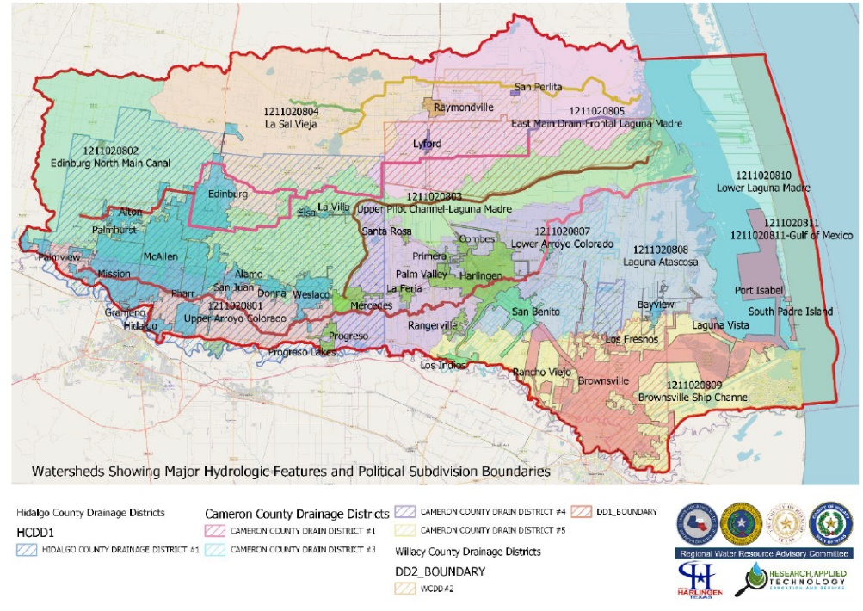urban areas and drainage districts (hatched). This figure also illustrates the inherent complexity of the LRGV hydrology. Man-made drainage ditches and irrigation canals transect natural elevation-based watersheds, rendering the USGS Hydrologic Unit classification ineffective as a first step in characterizing hydrology in the LRGV. Further, the layering of political jurisdictions, including counties, municipalities, and irrigation and drainage districts create a complex morass of management challenges.

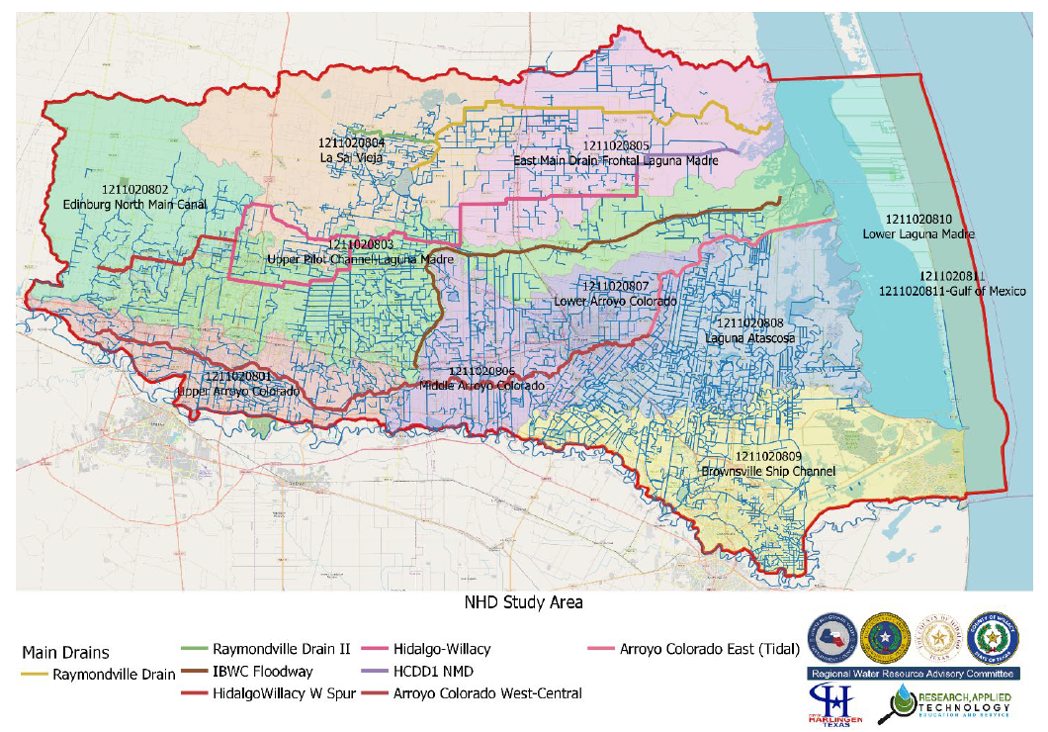The following figure depicts the local drainage network within the LRGV overlaid on the 5 main drains within the constituent HUC-10s. This figure demonstrates the need for layered basin characterization, with regional drainage patterns through the major drainage patterns being fed by more sub-regional drainage networks. The sub-regional networks can be visualized in the figure as the HUC-10 polygons but will most likely need to be manually delineated at the HUC-12 or HUC-14 scale to incorporate the effects of drainage ditches transecting elevation-based hydrologic boundaries. Localized hydraulics must be characterized at an even smaller scale (subdivision or urban sector) in order to be effectively used to drive design development exercises.

The specific approach will be tiered as follows:  
Regional: HUC-8 (12110208) with aggregated HUC-10 sub-regions and Main Drains burned-in (see Question 9 for Map).

1. Sub-Regional: Re-delineated HUC-10s using 2018 LiDAR data and National Hydrography Dataset (NHD) local drainage network burned-in.
2. Urban: Selected urban drainage networks not included in other on-going or projected studies.
3. Project Specific: Specific high-value Drainage Characterization and Feasibility Assessments solicited from urban areas defined in Tier 3

**EXHIBIT B**

SCOPE OF WORK

The Lower Rio Grande Valley Development Council will conduct planning of the entire South Laguna Madre HUC-8 (12110208) watershed to *“better inform the development of strategies using structural and nonstructural measures before a flood event, such as determining and describing problems from or related to flooding, identifying and planning solutions to flooding problems, and estimating the benefits and costs of these solutions.”*

The long-term goal of this project is to develop the regional knowledge-based decision support infrastructure to identify and promote the implementation of local flood management physical and non-structural controls that maximizes regional benefit. This goal will be achieved by advancing two parallel inter-dependent objectives:

* Objective 1: Regional Coordination & Technical infrastructure
* Objective 2: Identification, Assessment & Prioritization of Regional Flood Control Projects

A. Project Organization

LRGVDC personnel will serve as project leads responsible for direct oversight of contractors and will report directly to the TWDB. Project construction documents. RATES will provide outside consulting functions with respect to preparation of work proposed herein and with integration of other regional TWDB category 1 proposal initiatives into the LRGVDC Regional Flood Protection Planning Study, including abridged applications:

* 13800 Raymondville. Raymondville Watershed Study (HUC-10s 1211020804 & 1211020805)
* 13609 Cameron County Drainage District #3 (CCDD#3) Flood Protection Study (HUC-10s 1211020806, 1211020807, 1211020808, 1211020809)
* 13774 Willacy County. Willacy County Watershed Study (HUC-10s 1211020803, 1211020804 & 1211020805)
* 13647 Brownsville. Flood Protection Study (HUC-10 1211020809)
* 13528 Harlingen. Flood Protection Planning Study (HUC-10s 1211020806, 1211020807)

RATES will coordinate these efforts with the Lower Rio Grande Valley Development Council Regional Water Resource Advisory Committee (LRGV/RWRAC) to ensure maximum regional benefit. The LRGVDC will contract with qualified consulting engineering service providers to perform Project Specific Tasks related to Drainage Characterization and Feasibility Assessments.

B. Description of how flood protection needs of the entire watershed will be considered

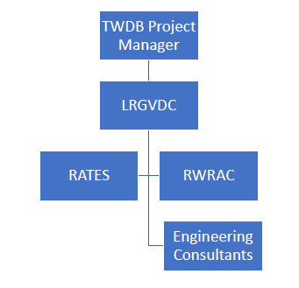See Objective 1: Regional Coordination & Technical Infrastructure below

C. Identification of Tasks

Objective 1: Regional Coordination & Technical infrastructure

*The LRGVDC will establish a regional coordination and decision-making network,*

*charged with the assimilation of hydrologic and hydraulic knowledge to support science-driven policy and decision making*

The end-point of this objective is to establish a continuous process by which local jurisdiction may be able to work together, relying on a shared, common hydrology operating picture to select solutions for local flooding that can be mutually beneficial, cost-effective and technologically efficient. Once established, and maintained, this regional flood management decision support infrastructure will sustain the adoption of regional flood management projects beyond the life of this project. The knowledge base will continue to evolve to serve as a regional feeder to the proposed Texas Disaster Information System.

*Task 1.1 Regional Coordination*

The LRGVDC will identify, coordinate, and develop regional projects encompassing the lengths of the Hidalgo/Willacy Drain and the Arroyo Colorado river. The LRGVDC will convene a subcommittee of its Regional Water Resources Advisory Committee (RWRAC) to serve as the focal point for facilitating regionalization of local flood management projects. Costs associated with this task include administrative and technical staff, including the RWRAC Watershed Coordinator, as well as materials, supplies, travel, and other expenses associated with administration of a large project. Beyond the initial investment in developing the knowledgebase, further detail, coverage, and updates will be sustained by aligning future project engineering outcomes with the needs of the knowledgebase.

*Task 1.2 Regional Hydrology & Hydraulics*

Through the RWRAC, a comprehensive Hydrologic and Hydraulic (H&H) study, greater in local detail and scope to Watershed Assessments conducted by the U.S. Army Corps of Engineers under Section 729 of the Water Resources Development Act (WRDA) of 1986 as well as addressing two of the three major phases of a FEMA flood study - i.e. assessing the flows through a hydrologic study, and determining flood elevations and floodway via a hydraulic analysis. A suite of geographically dispersed, adaptive-resolution hydrologic and hydrodynamic models will be developed in parallel to projects identified in Task 2.1 to support flood mitigation planning. Approximately 40 hydrologic units will be characterized and modeled, ranging in geographic scope from HUC8 to HUC16, with hydraulic modeling to be conducted on a subset of each sub-watershed, but constrained to a catchment scale defined by the projects identified in Task 2.1 (Project Identification). Costs associated with this task are primarily supplies, equipment and time-and-effort expended on data collection, model development, calibration and validation.

Task 1.2 is broken into 4 Activities:

* Activity 1.2.1 Data Collection & Assimilation
* Activity 1.2.2 Regional Modeling
* Activity 1.2.3 Sub-Regional Modeling
* Activity 1.2.4 Urban Modeling

Activity 1.2.1 Data Collection & Assimilation

This Activity, conducted over the 1st 18 months of the project, consists of the following subtasks:

* Historical Data Collection: Collection of hydrographic data from previous efforts conducted at the local, district, county or state level. Anticipated costs include approximately 12-person months of effort and associated equipment and supplies.
* Ground Truthing and Field Data Collection: Determination of quality control parameters for all collected data to ensure conformance with FEMA standards. Anticipated costs include approximately 20-person months of effort and associated equipment and supplies.
* Validation of all Collected Data: Validation of the collected data for use in modeling and drainage characterization effort for consistency and use applicability. Anticipated costs include approximately 12-person months of effort and associated equipment and supplies.
* Assimilation of Collected Data: Assimilation of the collected data into the REON.cc cyberinfrastructure for direct access by end-users, analytics and modeling functions, including transformation into useful formats (e.g. LiDAR->Delineated Watersheds). Anticipated costs include approximately 6-person months of effort and associated equipment and supplies.

Hydrographic data will be collected from each of the counties, municipalities, irrigation and

drainage districts to serve as the initial basis for field survey validation and ground-truthing. LiDAR data exists for the entire LRGV from a 2018 USGS flight. The figures below demonstrate the use of LiDAR data in watershed delineation in the Lower Laguna Madres/Brownsville Ship Channel areas to produce sub-watersheds on the order of HUC-12 or HUC-14, sufficient for both hydrologic and hydraulic modeling. All data and model scenarios will be house in an open-access cyberinfrastructure. This work was executed under Clean Water Act Section 319 projects funded through the Texas Commission on Environmental Quality.

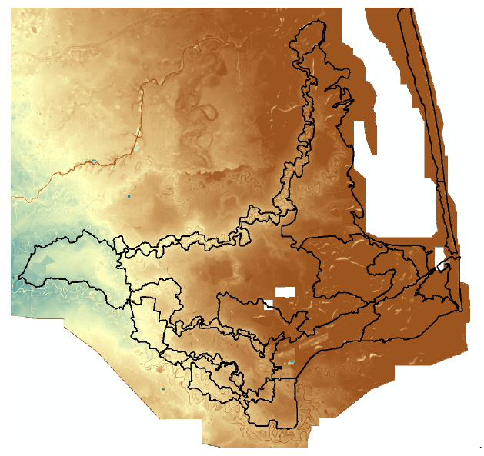

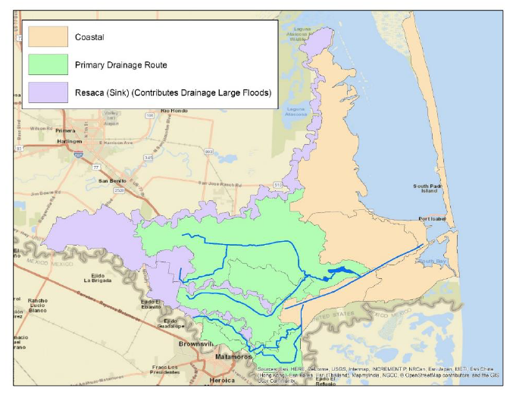

Activity 1.2.2 Regional Modeling

This Activity conducted over the 2nd 12 months of the project will involve coarse-grid hydrologic modeling over the 4 Study Basins defined previously (Hidalgo/Willacy North, IBWC Floodway, Arroyo Colorado, and the Lower Laguna Madre/Brownsville Ship Channel). In addition to the Study Basin scale watershed modeling, hydrodynamic modeling will be conducted on each of the 5 major drainage pathways (Raymondville Drain. Hidalgo/Willacy Drains, IBWC Floodway, Arroyo Colorado and the Brownsville Ship Channel). These models incorporate the effects of tidal fluxes at the mouths entering the Laguna Madre and will integrate coastal circulation patterns both modeled and monitored in the Lower Laguna Madre to identify the effects of storm surge. These models will be developed with the intent of generating on-demand forecasts based on meteorological predictions and integrated into the REON.cc cybercollaboratory. Anticipated costs include approximately 18-person months of effort and associated equipment and supplies.

Activity 1.2.3 Sub-Regional Modeling

This Activity, conducted over the 2nd 12 months of the project, will build on the further redelineation of the LRGV into LiDAR and flow path burn-in driven HUC-12 or HUC-14 subwatersheds as demonstrated above. Modeling efforts will be conducted at the sub-region (I.e. re-delineated HUC-10) scale and will focus on predicting hydrodynamic flows within each sub watershed (HUC-12-14), validated against observed (RTHS) data. Model datasets for each subregion will be compiled and served from the REON.cc cyberinfrastructure for use by local jurisdictions and their consultants. It is anticipated that the LRGV will result in the delineation of between 6-10 sub-regions. Anticipated costs include approximately 12-person months of effort and associated equipment and supplies.

Activity 1.2.4 Urban Modeling

There are approximately 22 municipalities identified within the LRGVDC service area (I.e.

excluding the urban areas to be served by the Raymondville, Brownsville, Harlingen and

Cameron County Drainage District #3 Watershed Studies, but including other urban areas in Willacy County). Stormwater models will be developed for each municipality using wherever available, existing storm drain network data (to be augmented in Activity 1.2.1). As with subregional modeling, urban hydrodynamic model datasets will be house and served from the REON.cc cyberinfrastructure for use by municipalities and their consultants. Anticipated costs include approximately 40-person months of effort and associated equipment and supplies.

*Task 1.3 Real Time Hydrologic Stations*

In parallel to the adaptive-resolution hydrologic and hydraulic characterization of the watershed, a network of Real Time Hydrologic Stations (RTHS) will be deployed across the LRGV as a catalyst for inter-jurisdictional collaboration and holistic flood, water quality and ecological management. RTHS deployments will be strategically located to serve the following decision making needs:

* Locations on the main drains and Resaca networks to characterize regional drainage patterns and to promote holistic decision making regarding regional flood-flow routing and siting of Regional Detention Facilities.
* Local, off-mainstem locations to provide flood-front early warning for localities experiencing recurring flooding, and to validate catchment-scale hydraulic models used for design development of structural controls such as high-volume pumping and major diversion structure or culverts.

The combination of adaptive resolution forecasting and validation with RTHS data will provide high confidence in early warnings. Further, as has been used in other water management domains (drinking water distribution and wastewater collection), deviations between model forecasts and RTHS data can be used to identify impending structural failures.

The RTHS deployments will be served by the River and Estuary Observation Network (REON) Cyberinfrastructure (REON.cc) that has been in continuous operation for 15 years, currently serving over 70 RTHS in providing real time decision support hydrologic and water quality data to local, regional and state decision makers.

RTHS sensors and base stations are designed, developed and deployed by Research, Applied Technology, Education and Service, Inc. (RATES) with a primary vision of “democratizing water intelligence” by making them affordable to small organizations. This is accomplished by reducing the component and life cycle of the incorporated technologies without sacrificing reliability, accuracy and precision. Operational costs are further reduced, and deployment sustainability is maximized by providing deployment strategies via a membership subscription model. This affords member entities turnkey solutions with nominal initial and ongoing annual investments.

A basic RTHS unit, consisting of base station with cellular telemetry, a full meteorological

sensor suite, and a stage height sensor with surveyed location and elevation and discharge

rating curves developed annually is typically deployed within the LRGV for a $15,000 initial

investment and $10,000 annual operations cost thereafter. Ensuring the location and elevation of the RTHS is accurately surveyed enables water level recording relative to a standard datum across the REON network and for that data to by used within the REON.cc decision support framework for drainage network state triggered early warning rather simply based on immediate upstream or downstream conditions. RTHS deployments in tidally influenced locations or locations that experience flow reversals will be equipped with Acoustic Doppler Current Profilers (ADCP) to provide both velocity and total discharge. including ADCP capacity to an RTHS adds $30,000 in the first year, and $2,500 in annual operations cost thereafter. Annual operating costs for each RTHS will range from $10,000 to $12,500 (with ADCP) beyond the 3-year project period. It is fully anticipated that local jurisdictions will be able to “adopt” an RTHS and absorb

these costs to sustain the network.  
  
Real Time Hydrologic Stations (RTHS) will be installed to locally validate the models developed in Task 1.2 that will rapidly provide the LRGVDC with the framework to support flood mitigation and planning, along with specific applications to impacted localities for capital improvement project design development. Approximately 44 RTHS deployments are anticipated across the LRGV, with approximately 1/3 being deployed to characterize catchment hydraulics (identified in Task 2.1) along with flood early warning. REON network sustainability is promoted by recruiting jurisdictions local to each installation to absorb the stations annual maintenance costs beyond the project performance period. There are currently 3 RTHS locations active in the LRGV in the vicinity of Brownsville. These installations were funded in part by Cameron County in support of a TCEQ-funded Watershed Protection Planning project. A 4th station has been contracted for by the City of Mercedes and will be brought online as soon as field team deployments are feasible under COVID-19 restrictions. TWDB has also committed to funding the deployment of an additional 4 locations to support instream flows (water quality) assessment into the Laguna Madre. 5 of the RTHS stations will be positioned at the mouths of each of the 5 channelized regional drainage pathways with ADCPs to characterize tidal flux, and a further 7 will be deployed inland on major laterals (such as the Mission Lateral) where flow reversal has been observed.

This Task is broken over two activities:

* Activity 1.3.1 Installation & Provisioning, Year 1. The basis for estimating these costs are provided above and include personnel time and effort and associated equipment and supplies.
* Activity 1.3.2 Operation & Maintenance Years 2&3. The basis for estimating these costs are provided above and include personnel time and effort and associated equipment and supplies.

*Task 1.4 Cyberinfrastructure*

In order to effectively develop an adaptive regional strategy, and to implement as suite of

currently identified specific flood protection projects, the LRGVDC will adopt the established River and Estuary Observation Network (REON - https://REON.cc) as the cyber-infrastructure house relevant hydrographic data. REON is a network of local government entities that share hydrographic data and hydrologic information to facilitate policy and decision making across inter-dependent jurisdictions. REON consists of a cloud-enabled Geographic Information System (GIS), supported by a growing network of RTHS, with embedded analytics and decision support tools, allowing jurisdictional partners to share information, and maintain offline mirrors for local operations and archival. The REON framework facilitates multi-partner, asynchronous (e.g. local developer) contributions to the community data, providing the basis for ordnance enabled data upkeep and enhancement. For example, hydrographic data can be integrated by developers, regulators or community organizations as local projects dictate its production, such as hydrologic and hydrodynamic models that demonstrate compliance with drainage

ordinances. The existing REON.cc cyberinfrastructure will be extended to incorporate both on demand and real-time hydrologic and hydraulic model forecast and hindcast capability for each of the 40 watersheds, sub-watersheds and catchments defined in Task 1.2. In addition to embedding the hydrologic and hydraulic model frameworks to be used, geo-spatial data validation procedures will be implemented to ensure seamless execution by non-technical users for decision support.

Activities in this task include

* Activity 1.4.1 User Interface Enhancements. Enhancements to the current REON.cc web interface to incorporate decision support tools and model execution. Anticipated costs include approximately 4-person months of effort and associated equipment and supplies.
* Activity 1.4.2 Model Integration. Integration of the selected models into the REON.cc codebase and database. Anticipated costs include approximately 6-person months of effort and associated equipment and supplies. Equipment costs include High Performance Computing for model execution.
* Activity 1.4.3 Database Enhancements. Enhancements to the current REON.cc data structures to incorporate hydrographic and model run file data. Anticipated costs include approximately 6-person months of effort and associated equipment and supplies. Equipment costs include redundant database servers and storage arrays.

Objective 2: Identification, Assessment & Prioritization of Regional Flood Control Projects

*The LRGVDC shall identify local and regional capital improvement projects that support*

*regional flood management*

The local jurisdictions participating in this effort fall within the 5 primary drainage basins that transect the tri-county region: the Raymondville Drain; the Hidalgo-Willacy Main Drain; the IBWC Floodway; the Arroyo Colorado; and the Lower Laguna Madre/Brownsville Ship Channel Drainage Basin. Several capital improvement projects on or adjacent to these waterways are being submitted by the relevant local jurisdictions, while others are in the conceptual development stage.

The proposed regional project would leverage local jurisdictional representation and

engagement in the LRGVDC’s Regional Water Resource Advisory Committee (RWRAC) to

facilitate the characterization of local drainage basins and identification, feasibility assessment and development of Preliminary Engineering Reports for both structural and non-structural flood protection initiatives. The proposed improvements include adding storage capacity via increasing main channel and lateral linear storage; improvements to off-channel detention basins, including restoration of Resacas; the integration of near real-time monitoring for flood early warning, mitigation and planning; the adoption of an integrative cyber-infrastructure to ingest, manage, maintain and grow the hydrologic and hydrographic knowledgebase encompassing the entire Lower Rio Grande Valley; and the establishment of an interjurisdictional operational decision making and policy development institution for flood management.

The endpoint for this objective is to engage local jurisdictions in the identification. selection and production of feasibility assessment and project design development documents that can be used to identify shared sources of funding for construction. These projects will, by the nature of the selection process, seek to fully utilize the region's main drains to address both regional drainage and localized flooding.  
 *Task 2.1 Regional Flood Control Projects: Identification & Prioritization*

Specific local structural controls will be identified that will have regional impact along with locally implemented non-structural controls (e.g. drainage ordinances). For example, improvements proposed will be directly applicable to mitigating the impact of increased HCCD1-NMD flows that are anticipated following the completion of Hidalgo County-2018 bond projects that include: channel and culvert improvements; construction of off-line detention; construction of new stormwater drainage systems; and construction of pumping stations.

Once partially developed during the first year of project performance, the combination of RTHS data, H&H knowledge and models, and the REON.cc cyberinfrastructure will form the basis of collaborative, multi-jurisdictional discussions aimed at identifying and promoting for further development, drainage improvement infrastructure that embody the dual goals of maximizing regional drainage efficacy, while simultaneously alleviating localized flooding. These projects have been identified in partnership with over 25 local jurisdictions meeting the following criteria:

* Projects that would immediately alleviate local flooding
* Projects that provide a benefit to regional drainage
* A focus on projects that are not being submitted for funding from TWDB/FIF separately
* Projects that have immediate endpoint of feasibility assessment or design development - not construction

The change that these projects have of the local hydrography, along with their impact on local flooding and regional drainage will be used to update and validate the H&H knowledgebase.

Activity 1.1.1 Watershed Coordinator:

To encourage regional thinking to tackle localized flooding, all participating jurisdictions should share a common operating picture. The recently established Regional Water Resources Advisory Committee (RWRAC) serves as the integrative representative body for facilitation of regional solutions for localized flooding. Administrative and technical staff from the LRGVDC will work closely with the LRGV Watershed Coordinator, a unique, jointly funded technical resource for all 3 counties and participating local jurisdiction to promote measured regional, watershed scale solutions to address local hydrologic and water quality issues.

The LRGV Watershed Coordinator was established via a multi-party, inter-jurisdictional

Memorandum of Agreement with funding from Hidalgo, Cameron and Willacy Counties,

Research, Applied Technology, Education and Service, Inc, and administratively located at the LRGVDC. The jointly funded LRGV Watershed Coordinator position provides the basis for developing technical capacity in water resource management at the LRGVDC with the primary purpose of promoting regional collaboration on projects that maximize value for the LRGVDC constituent political jurisdictions.

The Watershed Coordinator is responsible for developing and maintaining shared geodatabases serving up-to-date regional hydrography, along with geo-located current and proposed local drainage improvements (both structural and non-structural). This knowledge base will serve as the platform for adaptive resolution hydrologic and hydrographic characterization of the region that can be used to support Federal Emergency Management Agency (FEMA) floodplain mapping. Adaptive resolution characterization will allow the development of a regional (HUC8) hydrologic hindcast and forecast model, with sub-basin scale integration of HUC12 - HUC16 scale detailed hydrologic models. By layering multi-scale hydrologic models, forecasts for early warning and inundation mapping, and hindcasts for regional planning and design-development can be produced on-demand. At a finer resolution, i.e. catchment or subdivision, energy-based hydraulic models, that require large data inputs and computational power, will similarly be developed, and/or assimilated in cases where recent models exist, to support specific local design development needs. This heuristic approach will provide both real-time basin-scale hydrologic and on-demand catchment-scale hydraulic forecasting for the public, regional partners and decision makers. Anticipated costs include approximately 4-person months of effort and associated equipment and supplies

*Task 2.2 Drainage System Characterization*

For specific project areas identified in Task 2.1, in coordination with the responsible municipality or appropriate special district, a detailed drainage system characterization effort will be conducted. This will include:

* Updating existing drainage criteria to incorporate Atlas-14 changes to rainfall.
* Mapping of the 100‐yr and 500‐yr floodplains for existing condition
* Identify areas of structural and major roadway flooding due to riverine conditions and
* propose solutions, including channel improvements, regional detention, channel bypass,

Approximately 25 project areas are anticipated to be identified, with approximately 2.5-person months of effort and associated equipment and supplies being expended on each. It is anticipated that these activities will be executed though interlocal Agreements between

LRGVDC and the appropriately local entity.

*Task 2.3 Project Assessments*

Feasibility assessments will be conducted on the projects identified in Task 2.1, individually, and combined to develop an adaptive flood-management strategy at the regional level. The assessments will culminate in PER that include initial constructed cost estimates and Cost-Benefit Analyses that evaluate alternatives, including a no-implementation cost.

Activity 2.3.1 Project Assessments

Approximately 25 projects currently at the conceptual stage will be identified for execution to the Feasibility or PER stage., with approximately 2,5-person months of effort and associated equipment and supplies being expended on each. It is anticipated that these activities will be executed though interlocal Agreements between LRGVDC and the appropriately local entity.

|  |  |  |
| --- | --- | --- |
| **Exhibit C** |  |  |
| Table C.1 Estimated Task Budget |  |  |
| **Task** | **Activity Cost** | **Task Cost** |
| Task 1.2 Regional Hydrology & Hydraulics |  | $ 3,040,000.00 |
| Activity 1.2.1 Data Collection & Assimilation (Regional, Sub-Regional & Urban) | $ 1,290,000.00 | |
| Activity 1.2.2 Regional Modeling (4 Study Basins, 6 Drainage Pathways) | $ 450,000.00 | |
| Activity 1.2.3 Sub-Regional Modeling (6 HUC-10s) | $ 300,000.00 | |
| Activity 1.2.4 Urban Modeling (20 Municipalities) | $ 1,000,000.00 | |
| Task 1.3 Real Time Hydrologic Stations |  | $ 1,960,000.00 |
| Activity 1.3.1 Installation & Provisioning, Year 1 | $ 840,000.00 | |
| Activity 1.3.2 Operation & Maintenance Years 2&3 | $ 1,120,000.00 | |
| Task 1.4 REON.cc Cyberinfrastructure |  | $ 400,000.00 |
| Activity 1.4.1 User Interface Enhancements | $ 100,000.00 | |
| Activity 1.4.2 Model Integration | $ 150,000.00 | |
| Activity 1.4.3 Database Enhancements | $ 150,000.00 | |
| Task 2.1 Project Identification |  | $ 100,000.00 |
| Activity 2.1.1 Watershed Coordinator | $ 100,000.00 | |
| **Total** |  | **$5,500,000** |

|  |  |
| --- | --- |
| Table C.2 Estimated Expense Budget |  |
| **CATEGORY** | **AMOUNT** |
| Administration | $ 550,000.00 |
| Permits | $ 228,900.00 |
| Planning | $ 2,947,000.00 |
| Project Management | $ 1,100,000.00 |
| Surveying | $ 674,100.00 |
| **Total** | **$ 5,500,000.00** |

|  |  |  |  |  |  |  |  |  |  |
| --- | --- | --- | --- | --- | --- | --- | --- | --- | --- |
| Table C.3 Estimated Deliverables Schedule | | |  | | | | | | |
| **Deliverable & Month** | | | **Amount** | | | | | | |
| **2021** | | | **$2,318,500.00** | | | | | | |
| **Qtr1** | | | **$42,500.00** | | | | | | |
| Mar | | | $42,500.00 | | | | | | |
| Delineate watershed (GIS) | | | $10,000.00 | | | | | | |
| REON.cc User interface Requirements Determination | | | $12,500.00 | | | | | | |
| RTHS Data Model | | | $10,000.00 | | | | | | |
| Validate watershed delineations (GIS) | | | $10,000.00 | | | | | | |
| **Qtr2** | | | **$362,500.00** | | | | | | |
| Apr | | | $88,000.00 | | | | | | |
| Initial LRGV Flood Map Development (GIS) | | | $10,000.00 | | | | | | |
| Initial RTHS Site identification (GIS) | | | $15,000.00 | | | | | | |
| REON.cc User Interface Predevelopment Plan | | | $12,500.00 | | | | | | |
| REON.cc User interface Requirements Validation | | | $12,500.00 | | | | | | |
| RTHS Data Integration Upgrade | | | $30,000.00 | | | | | | |
| RWRAC Briefing Report 1 | | | $8,000.00 | | | | | | |
| May | | | $25,000.00 | | | | | | |
| REON.cc User Interface Implementation | | | $25,000.00 | | | | | | |
| Jun | | | $249,500.00 | | | | | | |
| Cameron County Data Collection Workshop | | | $10,000.00 | | | | | | |
| End User Data Dictionary Workshop Cameron County | | | $6,000.00 | | | | | | |
| End User Data Dictionary Workshop Hidalgo County | | | $6,000.00 | | | | | | |
| End User Data Dictionary Workshop Willacy County | | | $6,000.00 | | | | | | |
| Field Survey Data Model | | | $10,000.00 | | | | | | |
| Hidalgo County Data Collection Workshop | | | $10,000.00 | | | | | | |
| Hydraulic Asset Inventory Data Model | | | $20,000.00 | | | | | | |
| Hydrologic Model Code Deployment Report | | | | | | $50,000.00 | | | | | | | |
| Local Data Availability Assessment Report | | | | | | $15,000.00 | | | | | | | |
| Reconnaissance- RTHS, assets, and additional transects | | | | | | $44,000.00 | | | | | | | |
| REON.cc User interface Quality Assurance Demonstration | | | | | | $12,500.00 | | | | | | | |
| State & National Data Availability Assessment Report | | | | | | $15,000.00 | | | | | | | |
| State & National Data Characterization Report | | | | | | $15,000.00 | | | | | | | |
| State & National Data Demonstration Workshop | | | | | | $20,000.00 | | | | | | | |
| Willacy County Data Collection Workshop | | | | | | $10,000.00 | | | | | | | |
| **Qtr3** | | | | | | **$908,000.00** | | | | | | | |
| Jul | | | | | | $372,000.00 | | | | | | | |
| Develop LRGV Water Resources Field Survey Manual | | | | | | $40,000.00 | | | | | | | |
| Horizontal RTHS Transect Extent | | | | | | $22,000.00 | | | | | | | |
| Hydraulic Asset Integration: Completion Report | | | | | | $30,000.00 | | | | | | | |
| Hydrologic Data Assimilation Report | | | | | | $50,000.00 | | | | | | | |
| Local Data Characterization Report | | | | | | $20,000.00 | | | | | | | |
| Local Data Demonstration Workshop | | | | | | $20,000.00 | | | | | | | |
| REON.cc Deployment | | | | | | $12,500.00 | | | | | | | |
| REON.cc User Interface End-User Acceptance Testing | | | | | | $12,500.00 | | | | | | | |
| RTHS Install 1 | | | | | | $15,000.00 | | | | | | | |
| RWRAC Briefing Report 2 | | | | | | $10,000.00 | | | | | | | |
| Site Access Instrument Submittal | | | | | | $110,000.00 | | | | | | | |
| Survey Data Integration into Database | | | | | | $30,000.00 | | | | | | | |
| Aug | | | | | | $315,000.00 | | | | | | | |
| Crowd Source Data Integration Process Definition | | | | | | $30,000.00 | | | | | | | |
| Hydrologic Data Assimilation into Database | | | | | | $30,000.00 | | | | | | | |
| Hydrologic Model Execution Prototype Report | | | | | | $50,000.00 | | | | | | | |
| Operational Hydrologic Model Report | | | | | | $50,000.00 | | | | | | | |
| RTHS Install 2 | | | | | | $15,000.00 | | | | | | | |
| RTHS Install 3 | | | | | | $15,000.00 | | | | | | | |
| RTHS Install 4 | | | | | | $15,000.00 | | | | | | | |
| RTHS Install 5 | | | | | | $15,000.00 | | | | | | | |
| RTHS Install 6 | | | | | | $15,000.00 | | | | | | | |
| RTHS Install 7 | | | | | | $15,000.00 | | | | | | | |
| RTHS Install 8 | | | | | | $15,000.00 | | | | | | | |
| Tier 1 Data Extraction Code Deployment Report | | | | | | $50,000.00 | | | | | | | |
| Sep | | | | | | $221,000.00 | | | | | | | |
| Hydraulic Model Data File Construction Code Deployment | | | | | | $50,000.00 | | | | | | | |
| RTHS Install 10 | | | | | | $15,000.00 | | | | | | | |
| RTHS Install 11 | | | | | | $15,000.00 | | | | | | | |
| RTHS Install 12 | | | | | | $15,000.00 | | | | | | | |
| RTHS Install 13 | | | | | | $15,000.00 | | | | | | | |
| RTHS Install 14 | | | | | | $15,000.00 | | | | | | | |
| RTHS Install 15 | | | | | | $15,000.00 | | | | | | | |
| RTHS Install 9 | | | | | | $15,000.00 | | | | | | | |
| Site Access Approval | | | | | | $66,000.00 | | | | | | | |
| **Qtr4** | | | | | | **$1,005,500.00** | | | | | | | |
| Oct | | | | | | $483,000.00 | | | | | | | |
| End-User Interface Development Report | | | | | | $50,000.00 | | | | | | | |
| Other Hydraulic Asset Surveys | | | | | | $100,000.00 | | | | | | | |
| RTHS Install 16 | | | | | | $15,000.00 | | | | | | | |
| RTHS Install 17 | | | | | | $15,000.00 | | | | | | | |
| RTHS Install 18 | | | | | | $15,000.00 | | | | | | | |
| RTHS Install 19 | | | | | | $15,000.00 | | | | | | | |
| RTHS Install 20 | | | | | | $15,000.00 | | | | | | | |
| RTHS Install 21 | | | | | | $15,000.00 | | | | | | | |
| RTHS Install 22 | | | | | | $15,000.00 | | | | | | | |
| RTHS Transect Surveys | | | | | | $220,000.00 | | | | | | | |
| RWRAC Briefing Report 3 | | | | | | | $8,000.00 | | | |
| Nov | | | | | | | $205,000.00 | | | |
| Hydraulic Model Execution Protoype Report | | | | | | | $50,000.00 | | | |
| Operational Hydraulic Model | | | | | | | $50,000.00 | | | |
| RTHS Install 23 | | | | | | | $15,000.00 | | | |
| RTHS Install 24 | | | | | | | $15,000.00 | | | |
| RTHS Install 25 | | | | | | | $15,000.00 | | | |
| RTHS Install 26 | | | | | | | $15,000.00 | | | |
| RTHS Install 27 | | | | | | | $15,000.00 | | | |
| RTHS Install 28 | | | | | | | $15,000.00 | | | |
| RTHS Install 29 | | | | | | | $15,000.00 | | | |
| Dec | | | | | | | $317,500.00 | | | |
| ADCP Add-on Install 1 | | | | | | | $15,000.00 | | | |
| ADCP Add-on Install 2 | | | | | | | $15,000.00 | | | |
| RTHS Install 30 | | | | | | | $15,000.00 | | | |
| RTHS Install 31 | | | | | | | $15,000.00 | | | |
| RTHS Install 32 | | | | | | | $15,000.00 | | | |
| RTHS Install 33 | | | | | | | $15,000.00 | | | |
| RTHS Install 34 | | | | | | | $15,000.00 | | | |
| RTHS Install 35 | | | | | | | $15,000.00 | | | |
| RTHS Install 36 | | | | | | | $15,000.00 | | | |
| RTHS Install 37 | | | | | | | $15,000.00 | | | |
| Tier 1 Implementation | | | | | | | $25,000.00 | | | |
| Tier 1 Real Time Hydrologic Model Development: Hidalgo/Willacy Drain | | | | | | | $40,000.00 | | | |
| Tier 1 Real Time Hydrologic Model Development: IBWC Floodway | | | | | | | $40,000.00 | | | |
| Tier 1 Real Time Hydrologic Model Instantiation: IBWC Floodway | | | | | | | $50,000.00 | | | |
| Tier 1 Real-Time Model Requirements Determination | | | | | | | $12,500.00 | | | |
| **2022** | | | | | | | **$1,489,500.00** | | | |
| **Qtr1** | | | | | | | **$608,000.00** | | | |
| Jan | | | | | | | $330,500.00 | | | |
| ADCP Add-on Install 3 | | | | | | | $15,000.00 | | | |
| ADCP Add-on Install 4 | | | | | | | $15,000.00 | | | |
| ADCP Add-on Install 5 | | | | | | | $15,000.00 | | | |
| ADCP Add-on Install 6 | | | | | | | $15,000.00 | | | |
| ADCP Add-on Install 7 | | | | | | | $15,000.00 | | | |
| ADCP Add-on Install 8 | | | | | | | $15,000.00 | | | |
| RTHS Install 38 | | | | | | | $15,000.00 | | | |
| RTHS Install 39 | | | | | | | $15,000.00 | | | |
| RTHS Install 40 | | | | | | | $15,000.00 | | | |
| RTHS Install 41 | | | | | | | $15,000.00 | | | |
| RTHS Install 42 | | | | | | | $15,000.00 | | | |
| RTHS Install 43 | | | | | | | $15,000.00 | | | |
| RWRAC Briefing Report 4 | | | | | | | $8,000.00 | | | |
| Tier 1 Deployment | | | | | | | $12,500.00 | | | |
| Tier 1 Real Time Hydrologic Model Development: Raymondville Drain | | | | | | | $40,000.00 | | | |
| Tier 1 Real Time Hydrologic Model Development: Rio Grande/Arroyo Colorado | | | | | | | $40,000.00 | | | |
| Tier 1 Real Time Hydrologic Model Instantiation: Hidalgo/Willacy Drain | | | | | | | $50,000.00 | | | |
| Feb | | | | | | | $215,000.00 | | | |
| ADCP Add-on Install 10 | | | | | | | $15,000.00 | | | |
| ADCP Add-on Install 11 | | | | | | | $15,000.00 | | | |
| ADCP Add-on Install 12 | | | | | | | $15,000.00 | | | |
| ADCP Add-on Install 9 | | | | | | | $15,000.00 | | | |
| RTHS Install 44 | | | | | | | $15,000.00 | | | |
| Tier 1 Real Time Hydrologic Model Development: Brownsville Ship Channel | | | | | | | $40,000.00 | | | |
| Tier 1 Real Time Hydrologic Model Instantiation: Raymondville Drain | | | | | | | $50,000.00 | | | |
| Tier 1 Real Time Hydrologic Model Instantiation: Rio Grande/Arroyo Colorado | | | | | | | $50,000.00 | | | |
| Mar | | | | | | | $62,500.00 | | | |
| Tier 1 Real Time Hydrologic Model Instantiation: Brownsville Ship Channel | | | | | | | $50,000.00 | | | | | |
| Tier 2 Sub-Regional Model Requirements Determination | | | | | | | $12,500.00 | | | | | |
| **Qtr2** | | | | | | | **$225,500.00** | | | | | |
| Apr | | | | | | | $95,500.00 | | | | | |
| RWRAC Briefing Report 5 | | | | | | | $8,000.00 | | | | | |
| Tier 2 Deployment | | | | | | | $12,500.00 | | | | | |
| Tier 2 Implementation | | | | | | | $25,000.00 | | | | | |
| Tier 2 On-Demand Sub-Regional Hydraulic Model Development - HUC10 1 | | | | | | | $30,000.00 | | | | | |
| Tier 2 On-Demand Sub-Regional Hydraulic Model Validation - HUC10 1 | | | | | | | $20,000.00 | | | | | |
| May | | | | | | | $80,000.00 | | | | | |
| Tier 2 On-Demand Sub-Regional Hydraulic Model Development - HUC10 2 | | | | | | | $30,000.00 | | | | | |
| Tier 2 On-Demand Sub-Regional Hydraulic Model Development - HUC10 3 | | | | | | | $30,000.00 | | | | | |
| Tier 2 On-Demand Sub-Regional Hydraulic Model Validation - HUC10 2 | | | | | | | $20,000.00 | | | | | |
| Jun | | | | | | | $50,000.00 | | | | | |
| Tier 2 On-Demand Sub-Regional Hydraulic Model Development - HUC10 4 | | | | | | | $30,000.00 | | | | | |
| Tier 2 On-Demand Sub-Regional Hydraulic Model Validation - HUC10 3 | | | | | | | $20,000.00 | | | | | |
| **Qtr3** | | | | | | | **$310,500.00** | | | | | |
| Jul | | | | | | | $58,000.00 | | | | | |
| RWRAC Briefing Report 6 | | | | | | | $8,000.00 | | | | | |
| Tier 2 On-Demand Sub-Regional Hydraulic Model Development - HUC10 5 | | | | | | | $30,000.00 | | | | | |
| Tier 2 On-Demand Sub-Regional Hydraulic Model Validation - HUC10 4 | | | | | | | $20,000.00 | | | | | |
| Aug | | | | | | | $120,000.00 | | | | | |
| RTHS O&M Year 2 1 | | | | | | | $10,000.00 | | | | | |
| RTHS O&M Year 2 2 | | | | | | | $10,000.00 | | | | | |
| RTHS O&M Year 2 3 | | | | | | | $10,000.00 | | | | | |
| RTHS O&M Year 2 4 | | | | | | | $10,000.00 | | | | | |
| RTHS O&M Year 2 5 | | | | | | | $10,000.00 | | | | | |
| RTHS O&M Year 2 6 | | | | | | | $10,000.00 | | | | | |
| RTHS O&M Year 2 7 | | | | | | | $10,000.00 | | | | | |
| Tier 2 On-Demand Sub-Regional Hydraulic Model Development - HUC10 6 | | | | | | | $30,000.00 | | | | | |
| Tier 2 On-Demand Sub-Regional Hydraulic Model Validation - HUC10 5 | | | | | | | $20,000.00 | | | | | |
| Sep | | | | | | | $132,500.00 | | | | | |
| RTHS O&M Year 2 10 | | | | | | | $10,000.00 | | | | | |
| RTHS O&M Year 2 11 | | | | | | | $10,000.00 | | | | | |
| RTHS O&M Year 2 12 | | | | | | | $10,000.00 | | | | | |
| RTHS O&M Year 2 13 | | | | | | | $10,000.00 | | | | | |
| RTHS O&M Year 2 14 | | | | | | | $10,000.00 | | | | | |
| RTHS O&M Year 2 8 | | | | | | | $10,000.00 | | | | | |
| RTHS O&M Year 2 9 | | | | | | | $10,000.00 | | | | | |
| Tier 2 On-Demand Sub-Regional Hydraulic Model Validation - HUC10 6 | | | | | | | $20,000.00 | | | | | |
| Tier 3 Urban Model Requirements Determination | | | | | | | $12,500.00 | | | | | |
| Tier 3 Urban Stormwater Model Development 1 | | | | | | | $30,000.00 | | | | | |
| **Qtr4** | | | | | | | **$345,500.00** | | | | | |
| Oct | | | | | | | $145,500.00 | | | | | |
| RTHS O&M Year 2 15 | | | | | | | $10,000.00 | | | | | |
| RTHS O&M Year 2 16 | | | | | | | $10,000.00 | | | | | |
| RTHS O&M Year 2 17 | | | | | | | $10,000.00 | | | | | |
| RTHS O&M Year 2 18 | | | | | | | $10,000.00 | | | | | |
| RTHS O&M Year 2 19 | | | | | | | $10,000.00 | | | | | |
| RTHS O&M Year 2 20 | | | | | | | $10,000.00 | | | | | |
| RTHS O&M Year 2 21 | | | | | | | $10,000.00 | | | | | |
| RWRAC Briefing Report 7 | | | | | | | $8,000.00 | | | | | |
| Tier 3 Deployment | | | | | | | $12,500.00 | | | | | |
| Tier 3 Implementation | | | | | | | $25,000.00 | | | | | |
| Tier 3 Urban Stormwater Model Development 2 | | | | | | | $30,000.00 | | | | | |
| Nov | | | | | | | $100,000.00 | | | | | |
| RTHS O&M Year 2 22 | | | | | | | $10,000.00 | | | | | |
| RTHS O&M Year 2 23 | | $10,000.00 | | | | | | |
| RTHS O&M Year 2 24 | | $10,000.00 | | | | | | |
| RTHS O&M Year 2 25 | | $10,000.00 | | | | | | |
| RTHS O&M Year 2 26 | | $10,000.00 | | | | | | |
| RTHS O&M Year 2 27 | | $10,000.00 | | | | | | |
| RTHS O&M Year 2 28 | | $10,000.00 | | | | | | |
| Tier 3 Urban Stormwater Model Development 3 | | $30,000.00 | | | | | | |
| Dec | | $100,000.00 | | | | | | |
| RTHS O&M Year 2 29 | | $10,000.00 | | | | | | |
| RTHS O&M Year 2 30 | | $10,000.00 | | | | | | |
| RTHS O&M Year 2 31 | | $10,000.00 | | | | | | |
| RTHS O&M Year 2 32 | | $10,000.00 | | | | | | |
| RTHS O&M Year 2 33 | | $10,000.00 | | | | | | |
| RTHS O&M Year 2 34 | | $10,000.00 | | | | | | |
| RTHS O&M Year 2 35 | | $10,000.00 | | | | | | |
| Tier 3 Urban Stormwater Model Development 4 | | $30,000.00 | | | | | | |
| **2023** | | **$1,192,000.00** | | | | | | |
| **Qtr1** | | **$338,000.00** | | | | | | |
| Jan | | $178,000.00 | | | | | | |
| ADCP O&M Year 2 1 | | $10,000.00 | | | | | | |
| ADCP O&M Year 2 2 | | $10,000.00 | | | | | | |
| ADCP O&M Year 2 3 | | $10,000.00 | | | | | | |
| ADCP O&M Year 2 4 | | $10,000.00 | | | | | | |
| ADCP O&M Year 2 5 | | $10,000.00 | | | | | | |
| ADCP O&M Year 2 6 | | $10,000.00 | | | | | | |
| ADCP O&M Year 2 7 | | $10,000.00 | | | | | | |
| RTHS O&M Year 2 36 | | $10,000.00 | | | | | | |
| RTHS O&M Year 2 37 | | $10,000.00 | | | | | | |
| RTHS O&M Year 2 38 | | $10,000.00 | | | | | | |
| RTHS O&M Year 2 39 | | $10,000.00 | | | | | | |
| RTHS O&M Year 2 40 | | $10,000.00 | | | | | | |
| RTHS O&M Year 2 41 | | $10,000.00 | | | | | | |
| RTHS O&M Year 2 42 | | $10,000.00 | | | | | | |
| RWRAC Briefing Report 8 | | $8,000.00 | | | | | | |
| Tier 3 Urban Stormwater Model Development 5 | | $30,000.00 | | | | | | |
| Feb | | $100,000.00 | | | | | | |
| ADCP O&M Year 2 10 | | $10,000.00 | | | | | | |
| ADCP O&M Year 2 11 | | $10,000.00 | | | | | | |
| ADCP O&M Year 2 12 | | $10,000.00 | | | | | | |
| ADCP O&M Year 2 8 | | $10,000.00 | | | | | | |
| ADCP O&M Year 2 9 | | $10,000.00 | | | | | | |
| RTHS O&M Year 2 43 | | $10,000.00 | | | | | | |
| RTHS O&M Year 2 44 | | $10,000.00 | | | | | | |
| Tier 3 Urban Stormwater Model Development 6 | | $30,000.00 | | | | | | |
| Mar | | $60,000.00 | | | | | | |
| Tier 3 Urban Stormwater Model Development 7 | | $30,000.00 | | | | | | |
| Tier 3 Urban Stormwater Model Development 8 | | $30,000.00 | | | | | | |
| **Qtr2** | | **$158,000.00** | | | | | | |
| Apr | | $58,000.00 | | | | | | |
| RWRAC Briefing Report 9 | | $8,000.00 | | | | | | |
| Tier 3 Urban Stormwater Model Development 9 | | $30,000.00 | | | | | | |
| Tier 3 Urban Stormwater Model Validation 1 | | $20,000.00 | | | | | | |
| May | | $50,000.00 | | | | | | |
| Tier 3 Urban Stormwater Model Development 10 | | $30,000.00 | | | | | | |
| Tier 3 Urban Stormwater Model Validation 2 | | $20,000.00 | | | | | | |
| Jun | | $50,000.00 | | | | | | |
| Tier 3 Urban Stormwater Model Development 11 | | $30,000.00 | | | | | | |
| Tier 3 Urban Stormwater Model Validation 3 | | | | | $20,000.00 | | | | | | | |
| **Qtr3** | | | | | **$298,000.00** | | | | | | | |
| Jul | | | | | $58,000.00 | | | | | | | |
| RWRAC Briefing Report 10 | | | | | $8,000.00 | | | | | | | |
| Tier 3 Urban Stormwater Model Development 12 | | | | | $30,000.00 | | | | | | | |
| Tier 3 Urban Stormwater Model Validation 4 | | | | | $20,000.00 | | | | | | | |
| Aug | | | | | $120,000.00 | | | | | | | |
| RTHS O&M Year 3 1 | | | | | $10,000.00 | | | | | | | |
| RTHS O&M Year 3 2 | | | | | $10,000.00 | | | | | | | |
| RTHS O&M Year 3 3 | | | | | $10,000.00 | | | | | | | |
| RTHS O&M Year 3 4 | | | | | $10,000.00 | | | | | | | |
| RTHS O&M Year 3 5 | | | | | $10,000.00 | | | | | | | |
| RTHS O&M Year 3 6 | | | | | $10,000.00 | | | | | | | |
| RTHS O&M Year 3 7 | | | | | $10,000.00 | | | | | | | |
| Tier 3 Urban Stormwater Model Development 13 | | | | | $30,000.00 | | | | | | | |
| Tier 3 Urban Stormwater Model Validation 5 | | | | | $20,000.00 | | | | | | | |
| Sep | | | | | $120,000.00 | | | | | | | |
| RTHS O&M Year 3 10 | | | | | $10,000.00 | | | | | | | |
| RTHS O&M Year 3 11 | | | | | $10,000.00 | | | | | | | |
| RTHS O&M Year 3 12 | | | | | $10,000.00 | | | | | | | |
| RTHS O&M Year 3 13 | | | | | $10,000.00 | | | | | | | |
| RTHS O&M Year 3 14 | | | | | $10,000.00 | | | | | | | |
| RTHS O&M Year 3 8 | | | | | $10,000.00 | | | | | | | |
| RTHS O&M Year 3 9 | | | | | $10,000.00 | | | | | | | |
| Tier 3 Urban Stormwater Model Development 14 | | | | | $30,000.00 | | | | | | | |
| Tier 3 Urban Stormwater Model Validation 6 | | | | | $20,000.00 | | | | | | | |
| **Qtr4** | | | | | **$398,000.00** | | | | | | | |
| Oct | | | | | $158,000.00 | | | | | | | |
| RTHS O&M Year 3 15 | | | | | $10,000.00 | | | | | | | |
| RTHS O&M Year 3 16 | | | | | $10,000.00 | | | | | | | |
| RTHS O&M Year 3 17 | | | | | $10,000.00 | | | | | | | |
| RTHS O&M Year 3 18 | | | | | $10,000.00 | | | | | | | |
| RTHS O&M Year 3 19 | | | | | $10,000.00 | | | | | | | |
| RTHS O&M Year 3 20 | | | | | $10,000.00 | | | | | | | |
| RTHS O&M Year 3 21 | | | | | $10,000.00 | | | | | | | |
| RWRAC Briefing Report 11 | | | | | $8,000.00 | | | | | | | |
| Tier 3 Urban Stormwater Model Development 15 | | | | | $30,000.00 | | | | | | | |
| Tier 3 Urban Stormwater Model Development 16 | | | | | $30,000.00 | | | | | | | |
| Tier 3 Urban Stormwater Model Validation 7 | | | | | $20,000.00 | | | | | | | |
| Nov | | | | | $120,000.00 | | | | | | | |
| RTHS O&M Year 3 22 | | | | | $10,000.00 | | | | | | | |
| RTHS O&M Year 3 23 | | | | | $10,000.00 | | | | | | | |
| RTHS O&M Year 3 24 | | | | | $10,000.00 | | | | | | | |
| RTHS O&M Year 3 25 | | | | | $10,000.00 | | | | | | | |
| RTHS O&M Year 3 26 | | | | | $10,000.00 | | | | | | | |
| RTHS O&M Year 3 27 | | | | | $10,000.00 | | | | | | | |
| RTHS O&M Year 3 28 | | | | | $10,000.00 | | | | | | | |
| Tier 3 Urban Stormwater Model Development 17 | | | | | $30,000.00 | | | | | | | |
| Tier 3 Urban Stormwater Model Validation 8 | | | | | $20,000.00 | | | | | | | |
| Dec | | | | | $120,000.00 | | | | | | | |
| RTHS O&M Year 3 29 | | | | | $10,000.00 | | | | | | | |
| RTHS O&M Year 3 30 | | | | | $10,000.00 | | | | | | | |
| RTHS O&M Year 3 31 | | | | | $10,000.00 | | | | | | | |
| RTHS O&M Year 3 32 | | | | | $10,000.00 | | | | | | | |
| RTHS O&M Year 3 33 | | | | | $10,000.00 | | | | | | | |
| RTHS O&M Year 3 34 | | | | | $10,000.00 | | | | | | | |
| RTHS O&M Year 3 35 | | | | | $10,000.00 | | | | | | | |
| Tier 3 Urban Stormwater Model Development 18 | $30,000.00 | | | | | | |
| Tier 3 Urban Stormwater Model Validation 9 | $20,000.00 | | | | | | |
| **2024** | **$500,000.00** | | | | | | |
| **Qtr1** | **$340,000.00** | | | | | | |
| Jan | $200,000.00 | | | | | | |
| ADCP O&M Year 3 1 | $10,000.00 | | | | | | |
| ADCP O&M Year 3 2 | $10,000.00 | | | | | | |
| ADCP O&M Year 3 3 | $10,000.00 | | | | | | |
| ADCP O&M Year 3 4 | $10,000.00 | | | | | | |
| ADCP O&M Year 3 5 | $10,000.00 | | | | | | |
| ADCP O&M Year 3 6 | $10,000.00 | | | | | | |
| ADCP O&M Year 3 7 | $10,000.00 | | | | | | |
| RTHS O&M Year 3 36 | $10,000.00 | | | | | | |
| RTHS O&M Year 3 37 | $10,000.00 | | | | | | |
| RTHS O&M Year 3 38 | $10,000.00 | | | | | | |
| RTHS O&M Year 3 39 | $10,000.00 | | | | | | |
| RTHS O&M Year 3 40 | $10,000.00 | | | | | | |
| RTHS O&M Year 3 41 | $10,000.00 | | | | | | |
| RTHS O&M Year 3 42 | $10,000.00 | | | | | | |
| RWRAC Briefing Report 12 | $10,000.00 | | | | | | |
| Tier 3 Urban Stormwater Model Development 19 | $30,000.00 | | | | | | |
| Tier 3 Urban Stormwater Model Validation 10 | $20,000.00 | | | | | | |
| Feb | $120,000.00 | | | | | | |
| ADCP O&M Year 3 10 | $10,000.00 | | | | | | |
| ADCP O&M Year 3 11 | $10,000.00 | | | | | | |
| ADCP O&M Year 3 12 | $10,000.00 | | | | | | |
| ADCP O&M Year 3 8 | $10,000.00 | | | | | | |
| ADCP O&M Year 3 9 | $10,000.00 | | | | | | |
| RTHS O&M Year 3 43 | $10,000.00 | | | | | | |
| RTHS O&M Year 3 44 | $10,000.00 | | | | | | |
| Tier 3 Urban Stormwater Model Development 20 | $30,000.00 | | | | | | |
| Tier 3 Urban Stormwater Model Validation 11 | $20,000.00 | | | | | | |
| Mar | $20,000.00 | | | | | | |
| Tier 3 Urban Stormwater Model Validation 12 | $20,000.00 | | | | | | |
| **Qtr2** | **$60,000.00** | | | | | | |
| Apr | $20,000.00 | | | | | | |
| Tier 3 Urban Stormwater Model Validation 13 | $20,000.00 | | | | | | |
| May | $20,000.00 | | | | | | |
| Tier 3 Urban Stormwater Model Validation 14 | $20,000.00 | | | | | | |
| Jun | $20,000.00 | | | | | | |
| Tier 3 Urban Stormwater Model Validation 15 | $20,000.00 | | | | | | |
| **Qtr3** | **$60,000.00** | | | | | | |
| Jul | $20,000.00 | | | | | | |
| Tier 3 Urban Stormwater Model Validation 16 | $20,000.00 | | | | | | |
| Aug | $20,000.00 | | | | | | |
| Tier 3 Urban Stormwater Model Validation 17 | $20,000.00 | | | | | | |
| Sep | $20,000.00 | | | | | | |
| Tier 3 Urban Stormwater Model Validation 18 | $20,000.00 | | | | | | |
| **Qtr4** | **$40,000.00** | | | | | | |
| Oct | $20,000.00 | | | | | | |
| Tier 3 Urban Stormwater Model Validation 19 | $20,000.00 | | | | | | |
| Nov | $20,000.00 | | | | | | |
| Tier 3 Urban Stormwater Model Validation 20 | $20,000.00 | | | | | | |
| **Grand Total** | **$5,500,000.00** | | | | | | |

**Exhibit D**

Guidelines for Authors Submitting Contract Reports   
to the Texas Water Development Board

# **1.0 Introduction**

The purpose of this document is to describe the required format of contract reports submitted to the Texas Water Development Board (TWDB). Our reason for standardizing the format of contract reports is to provide our customers a consistent, and therefore familiar, format for contract reports (which we post online for public access). Another reason for standardizing the format is so that we can more easily turn a contract report into a TWDB numbered report if we so choose. Remember that your report will not only be seen by TWDB staff, but also by any person interested in the results of your study. A professional and high-quality report will reflect well on you, your employer, and the TWDB.

Available upon request, we will provide a Microsoft Word template (used to write these instructions) that gives the fonts, spacing, and other specifications for the headings and text of the report. Please follow this template as closely as possible.

# **2.0 Formatting your report**

The TWDB format is designed for simplicity. For example, we use Times New Roman for all text. We use 12 point, single-spaced text, left justification for paragraph text, 18 point bold for first-level headings, and 14 point bold for second-level headings. Page numbers are centered at the bottom of the page. Other than page numbers, please refrain from adding content to the document header or footer. Page setup should use one-inch margins on all four sides.

## 2.1 Text

The best way to format your document is to use the styles described and embedded in the template document (Authors_Template.dot) that is available on request from the TWDB. To use the Authors_Template.dot file, open it in Word (make sure *.dot is listed under Files of type) and save it as a .doc file. Advanced users can add the .dot file to their computers as a template.

Make sure the formatting bar is on the desktop (to open, go to View🡪Toolbars🡪Formatting) or, to view all of the formatting at once, go to Format🡪Styles and Formatting and select Available Styles from the dropdown box at the bottom of the window. The formatting in the template document provides styles (such as font type, spacing, and indents) for each piece of your report. Each style is named to describe what it should be used for (for example, style names include Chapter Title, Body Text, Heading 1, References, and Figure or Table Caption). As you add to your report, use the dropdown list on the Formatting Toolbar or the list in the Styles and Formatting window to adjust the text to the correct style. The Authors_Template.dot file shows and lists the specifications for each style.

### *2.1.1 Title*

Give your report a title that gives the reader an idea of the topic of your report but is not terribly long. In addition to the general subject (for example, “Droughts”), you may include a few additional words to describe a place, methodology, or other detail focused on throughout the paper (for example, “Droughts in the High Plains of Texas” or “Evaluating the effects of drought using groundwater flow modeling”). Please capitalize only the first letter of each word except ‘minor’ words such as ‘and’ and ‘of’. Never use all caps. Use headings to help the reader follow you through the main sections of your report and to make it easier for readers to skim through your report to find sections that might be the most interesting or useful to them. The text of the report should include an executive summary and sections outlined in 4.4 of Attachment 1. Headings for up to five levels of subdivision are provided in the template; however, we suggest not using more than three or four levels of subdivision except where absolutely necessary. Please avoid stacked headings (for example, a Heading 1 followed immediately by a Heading 2) and capitalize only the first letter of headings or words where appropriate—never use all caps.

## 2.2 Figures and photographs

To publish professional-looking graphics, **we need all originals to be saved at 300 dots-per-inch** (dpi) and in grayscale, if possible, or in the CMYK color format if color is necessary. Excessive use of color, especially color graphics that do not also work in grayscale, will prevent us from publishing your report as a TWDB numbered report (color reproduction costs can be prohibitive). Preferred file formats for your original graphics are Adobe Illustrator (.ai), Photoshop (.psd), EPS with .tiff preview, .jpg, .png, or .tiff files. Refrain from using low resolution .jpg or .gif files. Internet images at 72 dpi are unacceptable for use in reports. All graphics shall be submitted in two forms:

1. Inserted into the Microsoft Word document before you submit your report. Ideally, inserted graphics should be centered on the page. Format the picture to downsize to 6 inches wide if necessary. Please do not upsize a graphic in Word.
2. Saved in one of the formats listed above.

### *2.2.1 Other graphics specifications*

It is easiest to design your figures separately and add them in after the text of your report is complete. Graphics should remain within the 1-inch page margins of the template (6 inches maximum graphic width). Be sure that the graphics (as well as tables) are numbered in the same order that they are mentioned in the text. Figures should appear embedded in the report after being called out in the text. Also, remember to include a caption for each graphic in Word, not as part of the graphic. We are not able to edit or format figure captions that are part of the figure. For figures and photographs, the caption should appear below the graphic. For tables, the caption should appear above.

### *2.2.2 Creating publication-quality graphics*

When designing a graphic, make sure that the graphic (1) emphasizes the important information and does not show unnecessary data, lines, or labels; (2) includes the needed support material for the reader to understand what you are showing; and (3) is readable (see Figures 1 and 2 for examples). Edward R. Tufte’s books on presenting information (Tufte, 1983; 1990; 1997) are great references on good graphic design. Cole Nussbaumer Knaflic’s website *Storytelling With Data* also provides freely accessible resources for designing infographics and data visualizations (<http://www.storytellingwithdata.com/blog>). Figures 1 through 3 are examples of properly formatted, easy to understand graphics. Do not include fonts that are less than 6 points.

For good-looking graphics, the resolution needs to be high enough to provide a clear image at the size you make them within the report. In general, 300 dpi will make a clear image and is the minimum resolution for all situations. Try to create your figures at the same size they will be in the report, as resizing them in Word greatly reduces image quality. Photographs taken with at least a two-megapixel camera (if using digital) and with good contrast will make the best images. Save the original, and then adjust color levels and size in a renamed image copy. Print a draft copy of your report to double-check that your figures and photographs have clear lines and show all the features that you want them to have.

Figures and photographs should be in grayscale. Color greatly adds to the cost of printing, so we are trying to keep it to a minimum. Also remember that your report may be photocopied, scanned, or downloaded and printed in black and white. For this reason, you should use symbols or patterns, or make sure that colors print as different shades in black and white. All interval or ratio data (data measuring continuous phenomena, with each color representing an equal interval) need to be displayed in a graded scale of a single color (Figure 3). This way your figures will be useful even as a photocopy.

If you need help with your graphics or have questions, please contact the TWDB graphics department at (512)936-0129.

### *2.2.3* *Use of Figures, Graphics, and Photographs*

Figures, photographs, and tables need to be your own unless you have written permission from the creator, publisher, or copyright holder that allows us to reprint them (we will need a copy of this permission for copyrighted material our records). All figures and photographs must cite the source in the legend, and include whether the material is in the public domain, used under a Creative Commons License (<https://creativecommons.org/licenses/>), or used with permission of the copyright holder. Use caution when using any figures or photographs taken off the Internet or from newspapers or magazines—these sources may be subject to copyright and must be cited properly and/or used by permission.

## 2.3 Tables

Tables should be created in Microsoft Word (see Table 1). Tables should include a minimal amount of outlining or bold font to emphasize headings, totals, or other important points. Tables should be numbered separately from figures, and captions should appear above the text of the table.

Table 1: A sample table. Note caption above table.

Table text heading*

|  |  |  |  |  |  |  |  |  |
| --- | --- | --- | --- | --- | --- | --- | --- | --- |
| Table text | 1940 | 1950 | 1960 | 1970 | 1980 | 1990 | 2000 | %GW |
| Table text | 15 | 441 | 340 | 926 | 196 | 522 | 83 | 97.4 |
| Table text | 64 | 944 | 626 | 173 | 356 | 171 | 516 | 99.9 |
| Total | 79 | 1385 | 966 | 1099 | 552 | 693 | 599 |  |

* A footnote should look like this using 10 point Cambria.  
%GW = percent groundwater  
Be sure to describe any abbreviations or symbols, and, unlike in this table, be sure to note the units!

# **3.0 Units**

Measurements should be in English units. Metric units may be included in parentheses after the English units.

# **4.0 Citations and references**

It is important to give credit for all external sources referenced in your report. Therefore, be sure to use the appropriate citations and include references in your paper.

## 4.1 In-text citations

Each piece of information you use in your report that comes from an outside source must be cited within the text using the author’s last name and the year of publication. If there are two authors, list the last name of each followed by the year, and if there are more than two authors, list the last name of the first author followed by “and others” and the year. For example: “the end of the Jurassic Period occurred approximately 145.5 million years ago (Gradstein and others, 2004).”

## 4.2 References

All sources that are cited within the report should be listed at the end of the paper under the heading References. The references should follow the guidelines in “Suggestions to Authors of the Reports of the United States Geological Survey” (Hansen, 1991). These are available online at <https://pubs.usgs.gov/unnumbered/7000088> (a link to the chapter “Preparing references for Survey reports,” p. 234-241, is found at <https://pubs.usgs.gov/unnumbered/7000088/sta28.pdf>). Several examples of complete reference citations are listed at the end of these guidelines. Be sure that any citations that appear in tables or figures are included in the reference list. Also, before submitting the report, please check that all the citations in the report are included in the reference list and all references in the reference list are cited in the report.

# **5.0 Submitting your report**

Before you submit your report, proofread it. Look for spelling and grammatical errors. Also, check to see that you have structured the headings, paragraphs, and sentences in your paper so that it is easy to follow and understand (imagine you are a reader who does not already know the information you are presenting).

# **6.0 Conclusions**

Following the instructions above and providing accurate and readable text, tables, figures, and citations will help to make your report useful to readers. Scientists may read your report, as well as water planners, utility providers, and interested citizens. If your report successfully conveys accurate scientific information and explanations to these readers, we can help to create more informed decisions about the use, development, and management of water in the state.

# **7.0 Acknowledgments**

Be sure to acknowledge the people and entities that assisted you in your study and report. For example:

We would like to thank the Keck Geology Consortium, the American Society of Civil Engineers, and the Texas Bar CLE for providing examples to use in developing these guidelines. In addition, we appreciate Mike Parcher for providing information on how to create publication-quality graphics, Shirley Wade for creating the data used in sample Figure 1, and Ian Jones for providing sample Figure 3.

# **8.0 References**

Gradstein, F.M., J.G. Ogg, and A.G. Smith, eds., 2005, A geologic time scale 2004: Cambridge, Cambridge University Press, 610 p.

Hansen, W.R., ed., 1991, Suggestions to authors of the reports of the United States Geological Survey (7th ed.): Washington, D.C., U.S. Government Printing Office, 289 p.

Tufte, E. R., 1983, The visual display of quantitative information: Cheshire, C.T., Graphics Press, 197 p.

Tufte, E. R., 1990, Envisioning information: Cheshire, C.T., Graphics Press, 126 p.

Tufte, E. R., 1997, Visual explanations: Cheshire, C.T., Graphics Press, 156 p.

# **9.0 Examples of references**

Arroyo, J. A., and Mullican, III, W. F., 2004, Desalination: *in* Mace, R. E., Angle, E. S., and Mullican, W. F., III, editors, Aquifers of the Edwards Plateau: Texas Water Development Board Report 360, p. 293-302.

Bates, R. L., and Jackson, J. A., 1984, Dictionary of geological terms: Anchor Press/Doubleday, Garden City, New York, 571 p.

Blandford, T. N., Blazer, D. J., Calhoun, K. C., Dutton, A. R., Naing, T., Reedy, R. C., and Scanlon, B. R., 2003, Groundwater availability of the southern Ogallala aquifer in Texas and New Mexico–Numerical simulations through 2050: contract report by Daniel B. Stephens and Associates, Inc., and the Bureau of Economic Geology, The University of Texas at Austin to the Texas Water Development Board, variably paginated.

Fenneman, N. M., 1931, Physiography of Western United States (1st edition): New York, McGraw-Hill, 534 p.

Hubert, M., 1999, Senate Bill 1–The first big bold step toward meeting Texas's future water needs: Texas Tech Law Review, v. 30, no. 1, p. 53-70.

Kunianski, E. L., 1989, Precipitation, streamflow, and baseflow in West-Central Texas, December 1974 through March 1977: U. S. Geological Survey Water-Resources Investigations Report 89-4208, 2 sheets.

Mace, R. E., Chowdhury, A. H., Anaya, R., and Way, S.-C., 2000, A numerical groundwater flow model of the Upper and Middle Trinity aquifer, Hill Country area: Texas Water Development Board Open File Report 00-02, 62 p.

Maclay, R. W., and Land, L. F., 1988, Simulation of flow in the Edwards aquifer, San Antonio Region, Texas, and refinements of storage and flow concepts: U. S. Geological Survey Water-Supply Paper 2336, 48 p.

For more examples of references, see p. 239-241 of “Suggestions to Authors of the Reports of the United States Geological Survey” at https://pubs.usgs.gov/unnumbered/7000088/sta28.pdf.

**10.0 Examples of figures**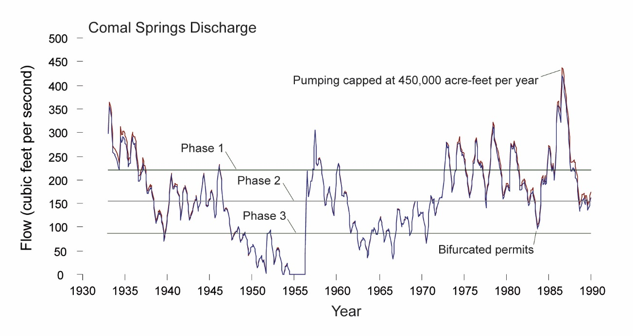

Figure 1. A sample figure showing only the information needed to help the reader understand the data. Font size for figure callouts or labels should never be less than 6 point.

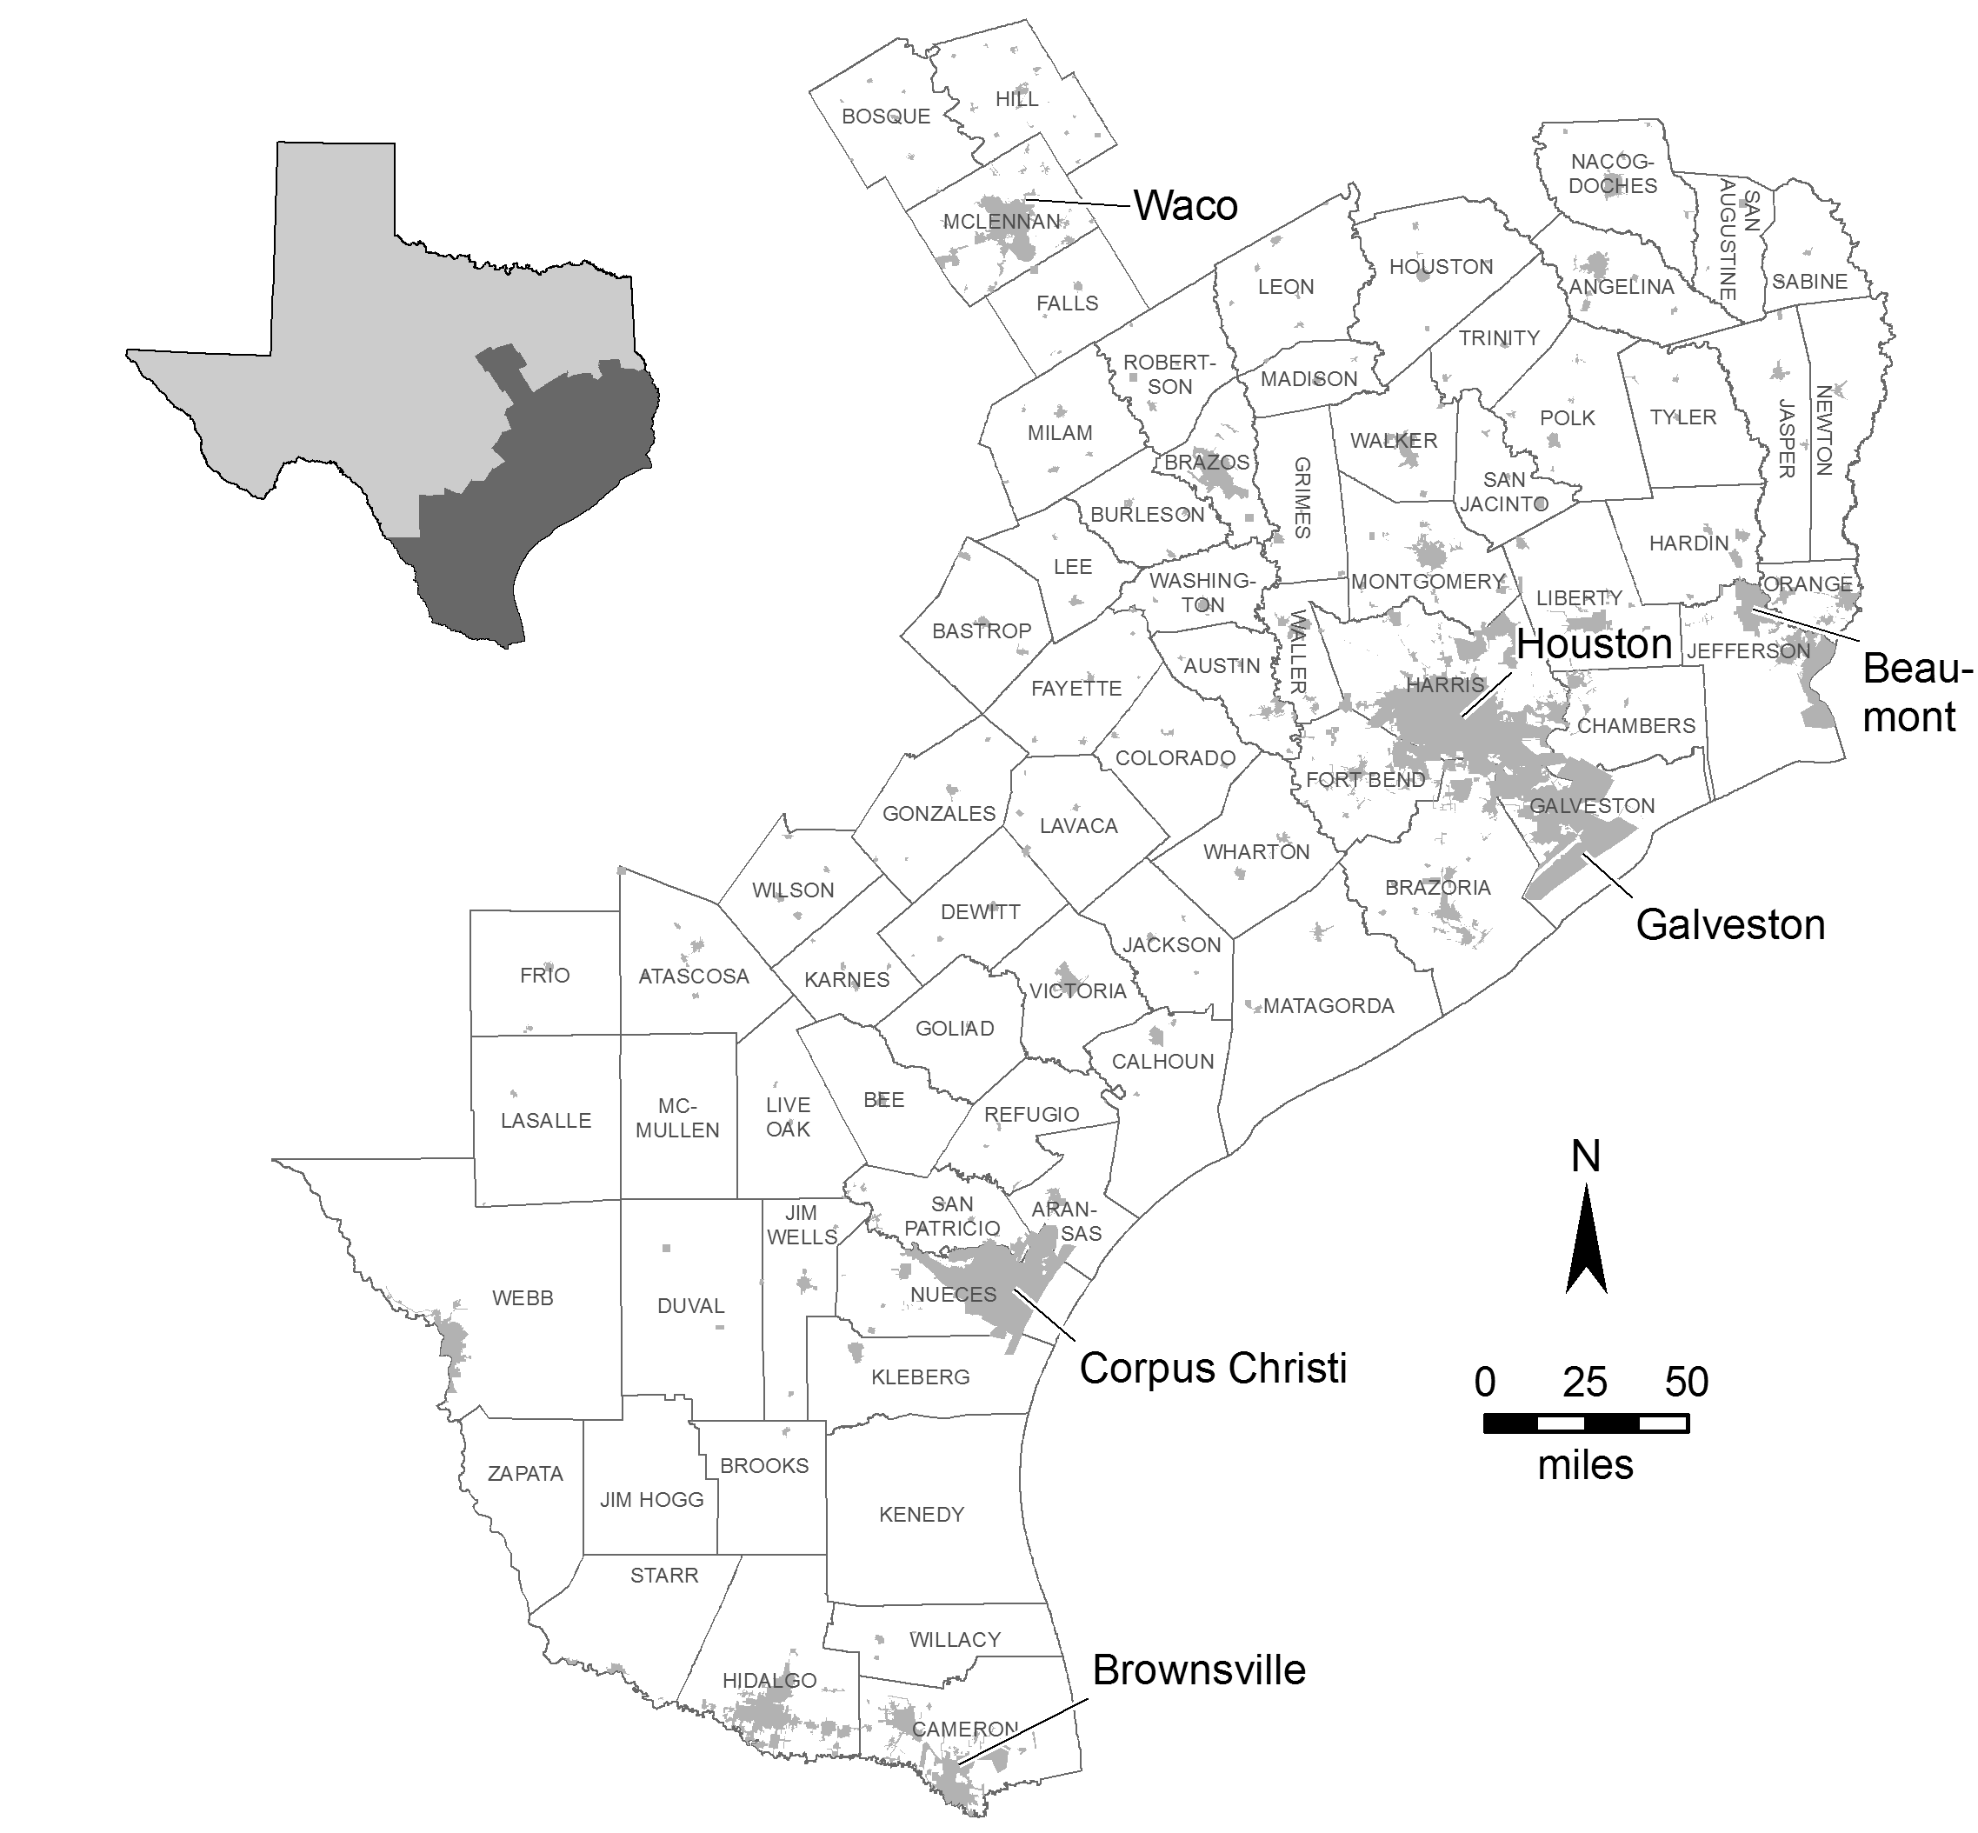

Figure 2. A sample subject area map, giving the reader enough information to understand the location being discussed in this conference. For map figures, be sure to include a north arrow to orient the reader, a scale, and, if needed, a submap that places the figure in greater geographic context. Be sure that text is readable and that any citations listed on the figure or in the figure caption are included in the reference list. Font size should never be less than 6 point.

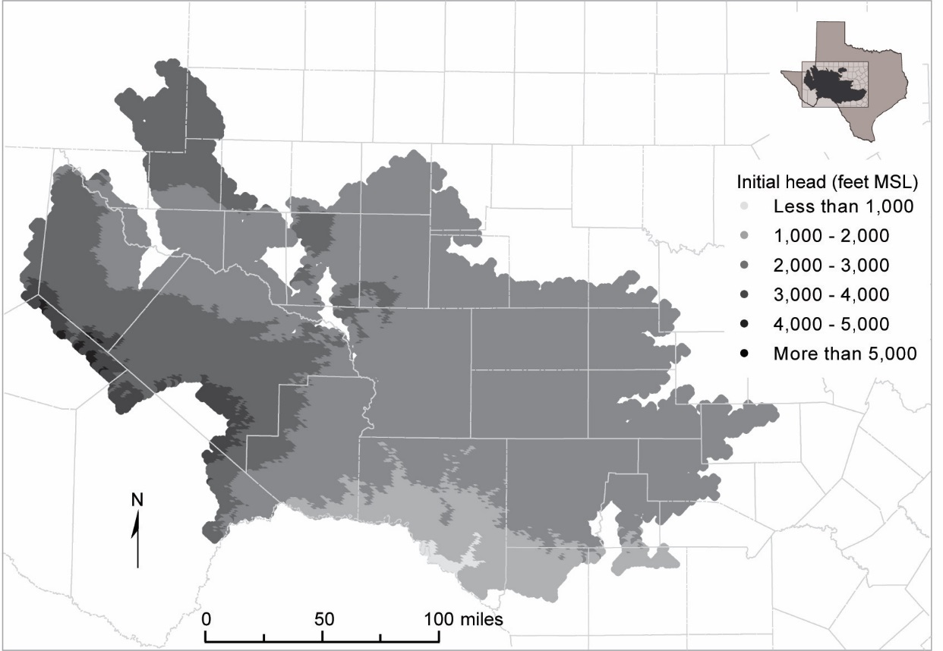

Figure 3. Initial hydraulic heads used in model simulations for layer 1. Note the use of grayscale shading to show differences

**EXHIBIT E**

**TWDB GUIDELINES FOR A PROGRESS REPORT**

Texas Water Development Board Borrowers/Grantees are required by their contracts to provide Progress Reports according to the ***“Payment Request Schedule”****.*

The progress report should contain the following standard elements:

* Date: Date the memo is sent
* To: Name and position of the reader
* From: Name and position of the writer
* Subject: TWDB Contract Number and the period that this report covers (i.e. Progress Report 09/01/18 – 11/30/18)

In-Kind Services: (*please include a value and description of any in-kind services provided during the reporting period*)

Work Completed: *(Explain what work has been done during the reporting period by Scope of Work task. Specify the dates of the reporting period and use active voice verbs to report progress made. Please include any updates on special conditions.)*

*For Example:*

Task 1: Completed 3 draft chapters and all appendices. Met with sub consultants on their chapters.

Task 2: Completed sample collection throughout river reach.

Task 3: No work completed in reporting period.

Problems: (*If the reader is likely to be interested in the glitches you have encountered along the way, mention the problems you have encountered and explain how you have solved them. If there are problems you have not yet been able to solve, explain your strategy for solving them and tell the reader when you think you will have them solved.*)